Advance-Decline Line
The popular Advance-Decline (AD) Line is a market breadth indicator, providing a very good measure of overall market strength
Overview
The Advance-Decline line measures the broad market strength represented by the New York Stock Exchange (NYSE). Historically, the AD Line peaks out well ahead of the more widely followed market indices and averages. It provides such useful information as:
- Overall market strength
- Rising or falling trends
- Whether the trend is intact, and
- The length of the current trend
The AD Line is calculated by taking the difference between the advancing and declining issues each day (usually on the NYSE). This positive or negative number is added to the cumulative AD line.
- When the AD line is positive, more stocks are advancing than declining and the A/D Line moves up
- When the AD line is negative, more stocks are declining than advancing and the A/D Line moves down
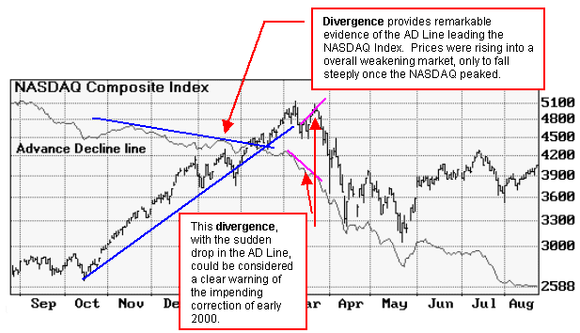

Interpretation
The AD Line is a good indicator of overall market strength; and many feel it is more revealing than popular indices such as the Dow Jones or the NASDAQ Composite Index. This is because the AD line is usually calculated on the NYSE, which represents the largest equities marketplace in the world with over 3,025 listed companies (see the Sidebar below).
In using the AD Line, keep an eye on the Trend and watch for Divergence from other indices or sectors:
Trend: By studying the trend of the AD Line you can see if the market is in a rising or falling trend, if the trend is still intact, and how long the current trend has prevailed.
Divergence: The AD line should trend in the same direction with the market averages. When the AD line peaks out ahead of the market, as it often does, investors are alerted to poor market breadth.
Typically, the daily AD Line is used to watch for short to intermediate trends. A weekly AD Line is considered more useful for trend comparisons that span several years.
Overbought/Oversold Indicator
The Overbought/Oversold Indicator (OB/OS) is simply a smoothed AD Line. The smoothing is done by taking the 10-day exponential moving average of the A/D Line. Smoothing the A/D Line makes it fluctuate within a narrower range with heavier weighting given to past data.
The OB/OS indicator generally fluctuates in a range of +400 to -400. A level above +200 suggests an overbought market while a level below -200 suggests an oversold market.

Further Information
There are a number of other useful indicators for measuring market breadth. See also the McClellan Oscillator, McClellan Summation Index, Upside-Downside Volume, and the Arms Index.
Sidebar on the NYSE
The New York Stock Exchange (NYSE) is the largest equities marketplace in the world and is home to 3,025 companies worth more than $16 trillion in global market capitalization. As of year-end 1999, the NYSE had 280.9 billion shares listed and available for trading worth approximately $12.3 trillion.
Over two-thirds of the roster of NYSE companies have listed here within the last 12 years. These companies include a cross-section of leading U.S. companies, midsize and small capitalization companies. Non-U.S. issuers play an increasingly important role on the NYSE. As of July 1999, 382 non-U.S. companies were listed here - more than triple the number 5 years ago

Bollinger Bands
Bollinger Bands provide several useful signals, including confirmation of trend and an indication of volatility.

Overview
Bollinger Bands can provide an indication of:
- whether prices are relatively high or low
- whether current trends are likely to continue or reverse
- the volatility of a market, based on the width of the band .
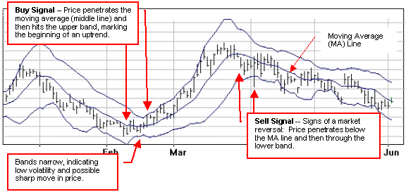
Developed by John Bollinger, this technique is one of the most popular forms of envelope or channel indicator. Two winding parallel lines above and below a central moving average (MA) create a band that contains the majority of price movements within a channel. This is similar to moving average envelopes. The difference is that Bollinger Bands are also sensitive to volatility in the market. The bands spread further apart during volatile markets and come closer together during calmer markets.
Technically speaking, moving average envelopes are plotted at a fixed percentage above and below a moving average, whereas Bollinger Bands are placed two standard deviations above and below the moving average, which is usually 20 days. Using two standard deviations ensures that 95% of the price data will fall between the two outside bands.

Interpretation
John Bollinger has written that, "Trading bands are one of the most powerful concepts available to the technically based investor, but they do not, as is commonly believed, give absolute buy and sell signals based on price touching the bands. What they do answer is the perennial question of whether prices are high or low on a relative basis." He goes on to say, "It is the action of prices near the edges of the envelope that we are particularly interested in."
As with most indicators, signals generated by Bollinger Bands should be confirmed using complimentary indicators. According to Bollinger, one of the biggest mistakes in technical analysis is the multiple counting of the same information. For example, using different indicators all derived from the same series of closing prices to confirm one another.
The indicators he recommends to complement Bollinger Bands are:
- RSI or MACD -- based on price alone
- On-Balance Volume (OBV) -- combining closing prices and volume
- Money Flow -- combining price range and volume
- He recommends against using the Commodity Channel Index (CCI) for the reason above
"See the description for each of these indicators for further information."

Signals
Bollinger Bands provide the following useful signals:
Trend: when prices move outside the bands, a continuation of the current trend is implied. Strongly trending markets will often stay touching and occasionally penetrating the band for long periods. Watch for initial penetrations of a band, particularly if other indicators confirm a potential move. When the bands are unusually far apart, the current trend may be ending. When the two bands are very tight, the market may be about to initiate a new trend.
Price targets: a move that originates at one band tends to go all the way to the other band. This observation can be used projecting price targets. For example, if prices bounce off the lower band and cross above the 20 day moving average, the upper band becomes the upper price target. A crossing below the 20 day average would establish the lower band as a price target.
Volatility (width of bands): sharp price changes tend to occur after the bands tighten, as volatility lessens.
Momentum: when the price moves above or below the Bollinger band then, on a subsequent move, fails to reach the band, you can interpret this as a loss of momentum and a reversal is possible. Many times the subsequent move will reach a higher or lower price but the loss of momentum is still indicated.
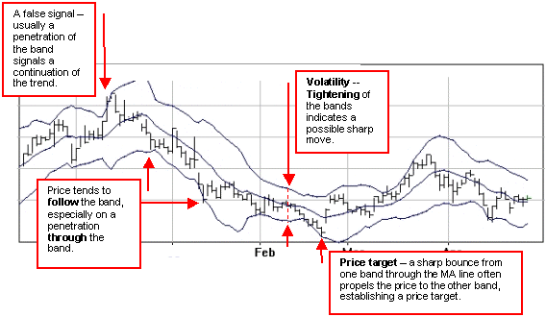

Commodity Channel Index
CCI is an oscillator that provides an indication of overbought or oversold markets.

Overview
- CCI is usually used as an overbought/oversold indicator
- CCI can also be used for timing buy/sell signals
The Commodity Channel Index, CCI, was designed to identify the beginning and the end of commodity market cycles by Donald Lambert. It has also proven effective for other markets. CCI compares the current mean price with the average mean price over a period of usually 20 days.
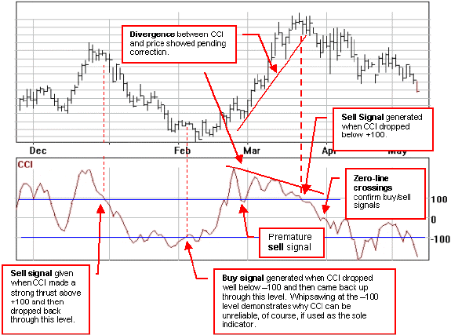

Interpretation
The CCI indicates the price is increasingly high compared to average prices as it moves towards +100. As the CCI drops towards -100, it indicates that the price is increasingly low compared to average prices.

Signals
- CCI provides a warning of overbought and oversold markets when the line crosses the +100 or the -100 levels. The actual buy or sell signal is usually provided, however, when the line then crosses back over the +/-100 level.
- Divergence from the price is also a good warning of a possible correction or trend reversal.
- Zero-line crossings can often provide a confirmation buy/sell signal or a complimentary warning of a change in trend.

Demand Index
Demand Index, DI, incorporates price and volume to give a ratio of buying pressure to selling pressure.
- DI is often a leading indicator of price change, based on the general observation that volume tends to peak before prices do.
- DI can be used with both daily and weekly data
DI is charted on an open scale and fluctuates above and below a zero line. When buying pressure is greater than selling pressure, the DI is above the zero line and vice versa. DI is one of the early volume indicators, developed in the 1970s by James Sibbet.
Interpretation
Several levels of interpretation can be used to help analyze the underlying trend.
Thomas Aspray, an experienced trader, suggests using DI in three formats:
- Plotting buying pressure (BP) and selling pressure (SP) as separate lines.
- Deriving an oscillator of the BP/SP which he calls the Demand Oscillator (charted as an histogram), and,
- The DI line itself (which can be charted as a line or as an histogram - although trendlines are more easily drawn on DI as a line)
Many experienced traders feel that weekly studies can be particularly important in identifying the predominant trend, and DI is often assessed using weekly data.
Signals
DI offers the following types of signals:
- Divergences between DI and price. A divergence between the DI and prices suggests an approaching change in the price trend.
- Trendline analysis of DI showing levels of support/resistance, can help determine changes in trend. As a leading indicator DI trendlines are often broken ahead of price trendlines
- Zero-line crossings can confirm previous signals as a lagging indicator.

ADX Directional Movement Index
DMI indicates when a trend is present and the overall strength of a market.

Overview
- The higher the DMI (on a scale of 0-100) the better the trend potential of a move.
- The DMI system is made up of three lines; ADX and +DI & -DI.
- DMI can be used either as a system on its own or as a filter for a trend-following indicator (i.e., Parabolic SAR).
The Directional Movement Index, DMI, is an effective and frequently used trend indicator. This system was designed by Welles Wilder Jr. and is made up of three lines:
- The +DI indicates the up average.
- The -DI indicates the down average.
- The ADX, average directional movement index, shows whether a trend is in effect by smoothing the difference between the +DI and -DI.
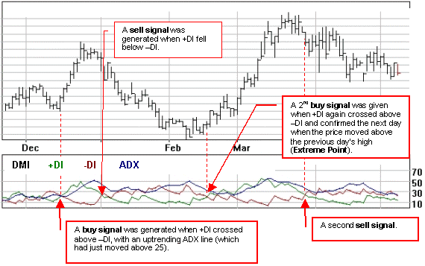
In the example above two clear buy signals have been generated. The first could have been ignored because ADX was very close to 25 - a potential danger signal. The second was perhaps more significant, even though ADX was trending downwards. It did provide a clear indication of the beginning of a very strong move in this market.
Buy and sell signals are given when +DI and -DI cross. The time periods most commonly used in the complex formula are 10 or 14 days.
According to Wilder the DMI should be used with the ADX as a filter.
- A rising ADX line means the market is trending and a better candidate for a trend-following system.
- A falling ADX line indicates a non-trending market.
- Some traders also look for an ADX greater than 20 or 25 to confirm that the market is trending. When the ADX line starts to drop from above the 40 level, that is an early sign that the trend is weakening. A rise back above 20 is often a sign of the start of a new trend.

Signals
Generally speaking, the two main buy and sell signals generated by DMI are as follows:
- A buy signal is given when +DI crosses above the -DI line.
- A sell signal is given when +DI crosses below the -DI line.
However, some refinements are suggested by experienced traders:
- The crossing of DI lines only provides an early warning signal; other criteria must be fulfilled for the actual signal.
- The ADX should be between the upper DI line and the lower one.
- An ADX below 25 is a strong warning to avoid trading.
Wilder himself developed a refinement to take care of whipsawing (when the DI lines cross back and forth over a short period, providing unreliable signals). He called it his Extreme Point Rule.
The Extreme Point Rule is derived by noting the high or low point on the day when the +DI and the -DI cross one another. +DI determines the high or low point (if +DI is above -DI the Extreme Point is the high of the day, if +DI is below -DI, the Extreme Point is the low for the day).
The extreme point is then used for the actual buy or sell signal. For example, if the price once again rises above the Extreme Point price level you have a buy signal. If the price fails to rise above the extreme point, you should continue to stand aside. The converse holds true for sell signals.

ADXR
An additional indicator, the average directional movement index rating (ADXR), was created by Wilder as a measuring tool for the strength of ADX. ADXR is the average of the current ADX and the ADX 14 days ago. ADXR is typically plotted alongside ADX on the same chart

Keltner Channel
The Keltner Channel is based on the Average True Range and is sensitive to volatility. It may be used in place of standard deviation (Bollinger) bands or percentage envelopes.
Overview
- The Keltner Channel is made up of two bands plotted around an Exponential Moving Average (EMA), usually the 20-day EMA.
- Prices breaking through the bands often produce buy and sell signals. The indicator was originally developed by Chester Keltner and later modified by Linda Raschke to use an average true range (ATR) calculated over 10 periods.
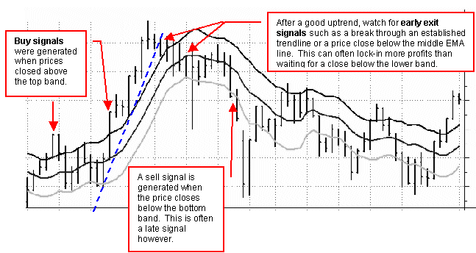
Interpretation
As with all envelope or band systems, the probability is that price will remain within the envelope. When price breaks though the envelope, it can be taken as a signal to either buy or sell.
When prices close above the top band, this often means a breakout in upward volatility to be followed by higher prices. When prices close below the bottom band, prices are expected to move lower.
In a rising market the middle line, or 20 period EMA, should provide support. Conversely, in a falling market it tends to provide resistance.
As with all trend following systems, the Keltner Channel works well in up trends or down trends, but doesn't work well in a sideways channel. As a trend following system it is not meant to catch tops or bottoms.
Keltner channels should be used in combination with other indicators, such as RSI or MACD, to provide confirmation of the strength of a market. An exit strategy utilizing trendlines and other indicators can be particularly important, as can be seen from the example above. Waiting for the price to close below the lower band often erodes much of the potential profits from a good move.
The calculation for Keltner Channel, based on ATR, is as follows:
- For the top or Plus Band, the ATR is calculated over 10 periods, doubled and added to a 20 period exponential moving average
- For the bottom or Minus Band, the ATR is calculated over 10 periods, doubles and subtracted from a 20 period exponential moving average
Signals
- When prices close above the plus band, it is a signal of strength and rising prices
- When prices close below the negative band, a signal that prices will drop is indicated
- Signals stay in effect until the prices close across the opposite band. This should often be tempered, however, with the use of other indicators to provide better exit opportunities

MACD
MACD is a useful indicator for spotting major changes in trend.
Overview
- MACD stands for Moving Average Convergence/Divergence.
- MACD is a trend following momentum indicator used to signal trend changes and to indicate trend direction.
- Signals are generated by crossovers and divergence from price.
The MACD method, developed by Gerald Appel, is a trending indicator, telling us whether a stock is in an uptrend or a downtrend. The direction of the long-term trend is the first assessment you should make of any market. If it is trending up, you want to be long (buying). If it is trending down, you want be short (selling). (This wouldn't necessarily hold true for to day traders, of course).
The simplest version of this indicator is composed of two lines: the MACD line, which is the difference between two exponential moving averages (EMAs) and a signal line, which is an EMA of the MACD line itself. The signal or trigger line is plotted on top of the MACD to show buy/sell opportunities. Gerald Appel's MACD method uses a 26-day and 12-day EMA, based on the daily close, and a 9-day EMA for the signal line.

Interpretation
The MACD proves most effective in trending markets rather than choppy, sideways markets. There are two main sets of signals generated by the MACD: crossovers and divergences.

Crossovers
There are two main MACD crossover signals:
- Signal Line Crossovers: MACD crosses above or below the signal line
- Zero Line Crossovers: MACD crosses above or below the zero line
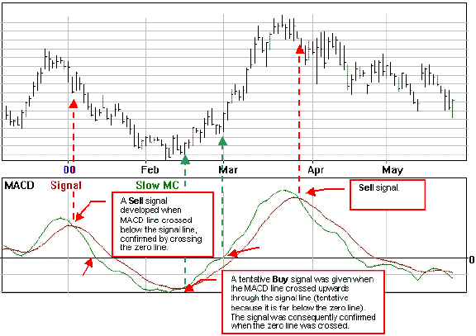

Signal Line Crossovers
The basic MACD trading rule is to buy when the MACD rises above its signal line. Similarly, a sell signal occurs when the MACD crosses below its signal line. The crossing of the MACD line above the signal line can denote the beginning of a trend. An uptrend typically pauses or stops when the MACD line crosses and falls below the signal line.
The location relative to the zero line is also important in indicating how strong a trend might be. A crossover above the zero line is considered more bullish than one below the zero line. The higher above the zero line it crosses, the stronger the uptrend. If the crossover occurs below the zero line, the uptrend is likely not very strong.
When the bullish crossover occurs above the zero line, the uptrend gains more momentum, and the price rises with more intensity.
Bullish MACD crossovers are probably the most common signals and as such can be less reliable. If not used in conjunction with other technical analysis tools, these crossovers can lead to whipsaws and many false signals.
One way to try and counteract false signals is to apply a price filter to the crossover to see if a trend will hold. An example of a price filter would be to buy if the MACD breaks above the signal line and remains above for three days. The buy signal would then commence at the end of the third day.

Zero Line Crossovers
The zero line can also be used to produce a signal. It is popular to buy/sell when the MACD crosses above/below the zero line.
A bullish zero line crossover occurs when MACD moves above the zero line and into positive territory. This is a clear indication that momentum has changed from negative to positive, or from bearish to bullish. After a positive divergence and bullish MACD crossover, the zero line crossover can act as a confirmation signal.

Divergence
MACD can provide forewarning of important market turns through divergence.
When the MACD trend diverges from the price trend, it can provide a signal that a trending market may slow or reverse. A negative, or bearish, divergence occurs when the MACD is making new lows while prices fail to reach new lows. A positive, or bullish, divergence occurs when the MACD is making new highs while prices fail to reach new highs. Both of these divergences are most significant when they occur at relatively high/low levels.
A positive divergence is shown when MACD begins to advance and the market is still in a downtrend and makes a new low. MACD can either form as a series of higher lows or a second low that is higher than the previous low. Positive divergences are not very common, but are usually reliable and can lead to good moves.
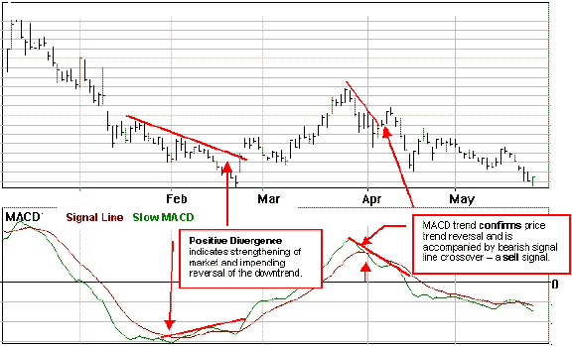
Combinations
Probably the best way to use the basic MACD is to use a combination of signals to confirm one another. In addition, a fast MACD line can be added to enhance the signals generated and to often provide early warning of changes in trends. An example of a three line MACD is shown below, with the signal line, the fast MACD line and the slow MACD line. The MACD Histogram is also commonly used to clarify the relationship between the two MACD lines.
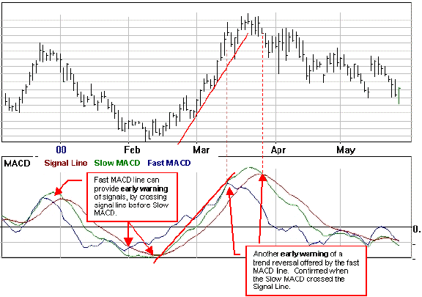

Weaknesses of MACD
MACD is a trend following indicator, and as such, sacrifices early signals in exchange for keeping you in line with the trend. When a significant trend develops, MACD is often able to capture the majority of the move. When the trend is short lived, however, MACD often proves unreliable.
This is because moving averages themselves are lagging indicators. Even though MACD represents the difference between two moving averages, there is still some lag in the indicator itself. This is more likely to be the case with weekly charts than daily charts. One solution to this problem is the use of the MACD-Histogram

McClellan Oscillator & McClellan Summation Index
A short to mid-term leading indicator, based on a market Index (NYSE, etc), showing overbought and oversold markets and providing a valuable timing tool.

Overview
Comprised of the daily advances minus declines of an Exchange, usually the New York Stock Exchange, with the weighted 20 and 40 day moving averages
- Indicates overbought markets above +125 and oversold below -125
- Used as an important timing tool based on bullish and bearish signals.
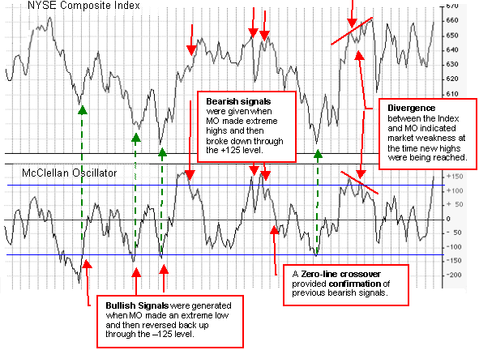
The McClellan Oscillator is calculated by subtracting a 39-day exponential moving average of the difference between the advancing issues and the declining issues from a 19-day exponential moving average of the difference between the advancing issues and the number of the declining issues in the Exchange.

Interpretation
The McClellan Oscillator is based on the movements of an Exchange, usually the New York Stock Exchange, not on any one particular stock. It is a short to mid-term "market breadth" indicator designed to determine the strength of a market trend. Market breadth is a measure of the percentage of stocks participating in a particular market move; if two-thirds of the stocks listed on an exchange move in the same direction during a trading session analysts say there was significant breadth.
The Oscillator produces three general types of signals:
- Divergence between the Index line and the indicator line 2.
- Overbought and oversold indications when the oscillator crosses the +125 and -125 levels 3.
- Zero line crossovers as the oscillator moves between positive and negative territory.
Signals
The McClellan Oscillator offers the following specific signals and alerts:
Divergence
The oscillator leads the index; so if it fails to confirm a new index high or low, the index may be forming a top or bottom. The example chart shows divergence between the index and the oscillator, with the oscillator indicating weakness. The Index subsequently plunged leaving behind a market top. Divergence can provide a warning, and should be combined with the other signals to produce definite entry and exit points.
Oversold/Overbought indications
- An overbought market is indicated when the oscillator enters territory above the +100 to +125 range. A bearish signal is provided when the oscillator forms a peak above +125 and then crosses back below this level.
- An oversold market is indicated when the oscillator enters territory below the -100 to -125 range. A bullish signal is provided when the oscillator forms a bottom below -125 and then crosses back above this level.
Zero-line Crossovers
- Bullish signal: upward movement through the zero line.
- Bearish signal: downward movement through the zero line.

McClellan Summation Index
The McClellan Summation Index (MSI) is a cumulative total of the McClellan Oscillator, useful for intermediate to long term trading. Both are based on the movements of a market Index (i.e., NYSE) rather than an individual stock. Major tops tend to occur when the MSI goes above +1500. Major bottoms tend to occur when the MSI dips below -1500 (the -2000 level may provide more reliable signals - see example below).
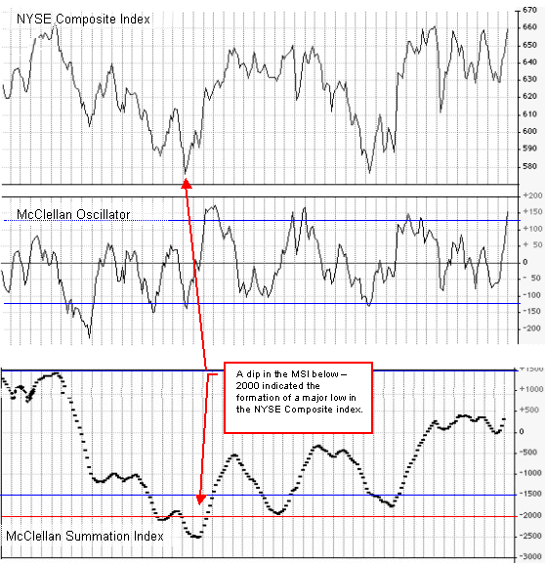

Money Flow Index
A divergence between the Money Flow Index and price trend can warn of a possible trend reversal.

Overview
- The Money Flow Index (MFI) tracks the flow of money into or out of a market.
- Price typically follows MFI and will eventually move in the same direction.
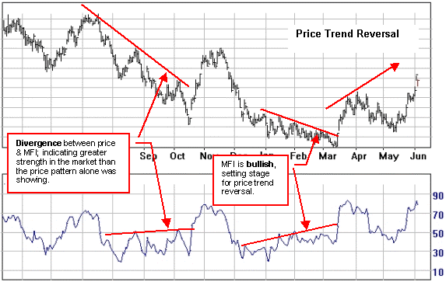
If a stock trades up 1 cent on 100 shares, and the next trade is down 1 cent on 10,000 shares, it shows that large sellers are more aggressive, and vice versa. Given that large-volume single trades are more significant than smaller-share trades, the Money Flow Index reflects this comparing today's average price with yesterday's and weighs the average price by volume. The volume of shares traded on upward moves is added up and then the volume of shares traded on downward moves is subtracted. The cumulative total for the day of every trade's volume is then plotted against a 0 - 100 scale. MFI is usually calculated over a 14 day period.
The Money Flow Index was developed by Laszlo Birinyi, Jr. as a real-time variation on the On-Balance Volume indicator. Instead of using each day as a reference point (as OBV does), MFI analyzes each trade. And instead of ignoring the price or the amount that the market is up or down, MFI weights each trade by price.
MFI is based on Money Flow but the two are not the same.

Interpretation
Money flow analysis is a volume weighted relative strength index. It is effective for both stock and company selection because it gives a view of a market's essential strength or weakness. Normally, MFI shows the same trends as the price pattern; indicating that, in an uptrend, money is flowing into the market, and when prices fall, money is flowing out of the market.
- Since Price - MFI divergences can exist for a fairly long period, other indicators should be used as confirmation and to select entry points
- Different time spans should be considered; often the longer the better.

Signals
- A divergence between price and MFI often signals an imminent reversal of the trend.
- Readings below 20 on the scale are considered oversold (bullish).
- Readings above 80 on the scale are considered overbought (bearish).
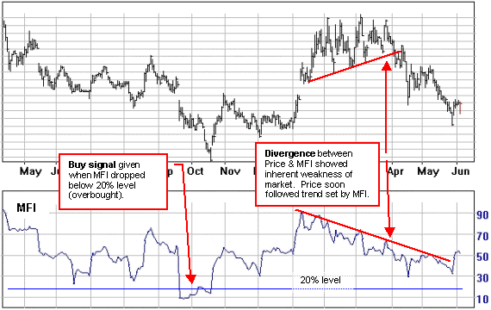

Momentum
Momentum measures the speed of price change and provides a leading indicator of changes in trend.

Overview
- The Momentum line leads price action frequently enough to signal a potential trend reversal in the market.
- Momentum indicators can warn of dormant strength or weakness in the price well ahead of the turning point.
- At extreme positive values, momentum implies an overbought position; at extreme negative values, an oversold position.
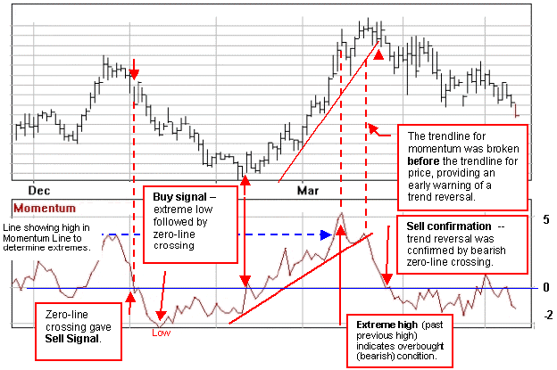

Interpretation
A strongly trending market acts like a pendulum; the move begins at a fast pace, with strong momentum. It gradually slows down, or loses momentum, stops, and reverses course.
The momentum line is always a step ahead of the price movement. It leads the advance or decline in prices and levels off while the current price trend is still in effect. It then begins to move in the opposite direction as prices begin to level off.
The 10 day momentum line fluctuates on an open scale around a zero line. When the latest closing price is higher than that of 10 days ago, a positive value is plotted above the zero line. If the latest close is lower than 10 days previous, a negative value is plotted.
Ten days or periods are usually used in calculating momentum, but any time period can be employed. The shorter the time frame used the more sensitive momentum becomes to short term fluctuations with more marked oscillations. Oscillator swings are smoother and more stable when a longer number of days are used.

Upward Momentum
When an uptrending momentum line begins to flatten out it means that the new gains being achieved by the latest closing prices are the same as the gains 10 days earlier. The rate of upward momentum has leveled off even though prices may still be advancing. When the momentum line begins to drop further, below the zero line, the uptrend in prices could still be in force, but the last price gains are less than those of 10 days ago. The uptrend is losing momentum.
Downward momentum
When the momentum line moves below the zero line, the latest close is now under the close of 10 days ago and a short term downtrend is in effect. As momentum continues to drop farther below the zero line, the downtrend gains momentum. The downtrend decelerates when the line begins to turn around.
If loss of momentum is experienced in a market at the same time as selling resistance is met or when buying power is temporarily exhausted, momentum and price peak simultaneously.

Signals
Momentum is a basic application of oscillator analysis, designed to measure the rate of price change, not the actual price level.
Three common signals are generated by the momentum oscillator: zero-line crossings, trendline violations, and extreme values.

Zero-line crossings
Although the long-term price trend is still the overriding consideration, a crossing above the zero line could be a buy signal if the price trend is up and a crossing below the zero line, a sell signal, if the price trend is down.

Using Trendlines
The trendlines on the momentum chart are broken sooner than those on the price chart. The value of the momentum indicator is that it turns sooner than the market itself, making it a leading indicator.

Extreme Values
One of the benefits of oscillator analysis is being able to determine when markets are in extreme areas. At extreme positive values, momentum implies an overbought position; at extreme negative values, an oversold position
The absence of a fixed upper and lower boundary presents a difficulty with the momentum line. To help solve this problem look at the long-term history of the momentum line and draw horizontal lines along its upper and lower boundaries. Adjust these lines periodically, especially after important trend changes.

Moving Averages

Moving Averages (MAs) provide a set of very useful indicators for tracking trends and trend reversals.

Overview
- The Moving Average is a lagging indicator, or trend following formula, that smoothes the volatile swings in a market.
- MAs are used to track the progress of a trend and to signal when a trend has ended or reversed.
- There are 4 common types of moving averages: simple, linearly weighted, exponential and variable.( See Table below for Types of Moving Averages)
The Moving Average (MA) is one of the simplest, yet most versatile and widely used of all technical indicators. The MA attempts to tone down the fluctuations of market prices to a smoothed trend, so that distortions are reduced to a minimum. MAs help in tracking trends and signalling reversals. You could think of the MA as a curved trendline, fitting itself to the market.
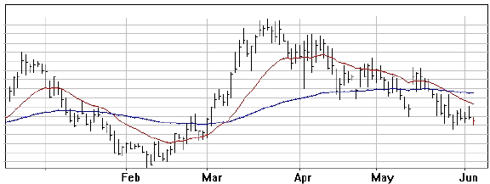

Interpretation
Signals to buy or sell are generated when the price crosses the MA or when one MA crosses another, in the case of multiple MAs. As with trendlines, the MA often provides an area of support and resistance. The more times an MA has been touched (i.e., acts as support or resistance) the greater the significance when it is crossed.
Since the MA is a lagging indicator, a crossover will usually signal a trend reversal well after a new trend has begun and is used largely for confirmation. Generally speaking, the longer the time span covered by an MA, the greater the significance of a crossover signal. For example, the crossover of a 100 or 200-day MA is significantly more important then the crossover of a 20-day MA.
Moving averages differ according to the weight assigned to the most recent data. Simple moving averages apply equal weight to all prices. Exponential and weighted averages apply more weight to recent prices. Variable moving averages change the weighting based on the volatility of prices.
When prices fluctuate up and down in a broad sideways pattern for an extended period (trading-range market), longer term MAs are slow to react to reversals in trend, and when prices move sideways in a narrow range shorter term MAs often produce false signals. Flat and conflicting MAs generally indicate a trading-range market and one to avoid, unless there is pronounced rounding that suggests a possible new trend.
Type of MA | Description | Methods Used
Simple  (This is the most commonly used MA) | Use of multiple MAs can provide good signals  Useful periods  Short term 10-30 day  Mid term 30-100-day  Long term 100-200+day  There is no perfect time span | Crossover of short term through long term  Convergence/ Divergence  Crossover of MA by price
Linearly Weighted | With this MA, data is weighted in favour of most recent observations.  Has the ability to turn or reverse more quickly than simple MA. | Warning of trend reversal given by change in direction of the average rather than crossover.
Exponential  (EMA) | An exponential (or exponentially weighted) moving average is calculated by applying a percentage of today's closing price to yesterday's moving average value. Exponential moving averages place more weight on recent prices. | Crossover of short term through long term  Convergence/ Divergence  Crossover of MA by price
Variable | An automatically adjusting exponential moving average based on the volatility of the data. | The more volatile the data, the greater the weight given to the current data and the more smoothing used in the moving average calculation.
The variable MA is able to compensate for trading-range versus trending markets. This MA automatically adjusts the smoothing constant to adjust its sensitivity, often allowing it to outperform the other moving averages in these difficult markets.
MAs should always be used in conjunction with other indicators because of the potential for false signals (whipsawing) and, particularly during sideways channels. MAs can be calculated on a security's open, high, low, close, volume, or on any other indicator. Indicators which are especially well-suited for being used with moving averages include MACD, Price ROC, Momentum, and Stochastics. A moving average of another moving average is also common.
Moving averages are helpful in keeping you in line with the price trend by providing buy signals shortly after the market bottoms out and sell signals shortly after it tops, rather than trying to catch the exact bottom or top.

Signals

Moving Average Price crossover
A price break upwards through an MA is generally a buy signal, and a price break downwards through an MA is generally a sell signal. As we have seen, the longer the time span or period covered by an MA, the greater the significance of a crossover signal.
If the MA is flat or has already changed direction, its violation is fairly conclusive proof that the previous trend has reversed.
False signals can be avoided by using a filtering mechanism. Many traders, for example, recommend waiting for one period - that is one day for daily data and one week for weekly data.
Whenever possible try to use a combination of signals. MA crossovers that take place at the same time as trendline violations or price pattern signals often provide strong confirmation.
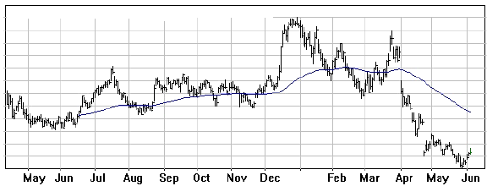

Multiple Moving Averages
It is usually advantageous to employ more than one moving average. Double and triple MAs often provide useful signals.
With two MAs the double crossover is used; a buy signal is produced when the shorter average crosses above the longer, and vice versa for the sell signal. For example, two popular combinations are the 5 and 20-day averages and the 20 and 100-day averages. The technique of using two averages together lags the market a bit more than a single moving average but produces fewer whipsaws.
The triple crossover method is also popular, using three moving averages. The most widely used triple crossover system is the popular 4-9-18-day MA combination. A buy signal is generated when the shortest (and most sensitive) average - the 4 day - crosses first the 9-day and then the 18-day averages, each crossover confirming the change in trend.
Additional Points:
- The 200-day MA(or 40-week MA), should be carefully watched as a pivotal level of support or resistance for the long-term trend. Many people watch carefully when the 200-day MA is approached by the price. The relationship between the price and its 200-day MA can often provide excellent buy or sell signals.
- The 200-day MA is also particularly significant for the various indexes, such as the Dow Jones or NASDAQ. A crossover of this MA has often signalled a correction or period of consolidation.
- Moving averages can also be calculated and plotted for other indicators, not just the price. A continued upward movement by the indicator is signified by the indicator rising above its moving average. A continued downward movement is signified by the indicator falling below its moving average.

Parabolic SAR
Parabolic SAR provides a useful tool for catching new trends early, offering excellent buy and sell signals.
Overview
- The Parabolic SAR (stop and reverse) is a trend-following system that sets "stop-losses."
- It works well in trending markets, but tends to whipsaw during non-trending, sideways phases.
- A parabola below the price is generally bullish.
- A parabola above the price is generally bearish.
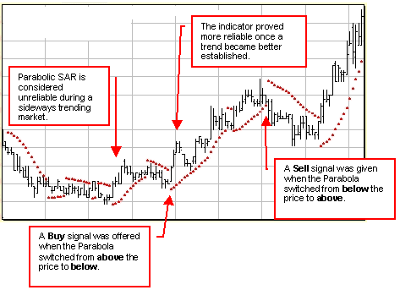
The Parabolic System, developed by Welles Wilder who also developed the Relative Strength Index (RSI), is usually referred to as the Parabolic "SAR" (stop-and-reverse). Mr Wilder designed this indicator to supplement the other trend-following systems.
The Parabolic SAR is a "stop-loss" system used to set trailing price stops. The name of the system is derived from its parabolic shape, which follows the price movements in the form of a dotted line. When the parabola follows along below the price, the trader should be buying or going long. A parabola above the price suggests selling or going short.
The particular value of the Parabolic SAR is that it allows traders to catch new trends relatively early. If the new trend fails, the parabola quickly switches from one side of the price to the other, thus generating the stop and reverse signal.
Mr. Wilder built an acceleration factor into the Parabolic system. To allow the trend time to become established, the movement of the indicator starts off slowly - with the dots close together. As acceleration increases, the parabola move faster (with the dots further apart) until it catches up to the price action.
As with most indicators, Parabolic SAR performs best in trending markets, and is less reliable during sideways or congestive phases.

Signals
The Parabolic SAR is an outstanding indicator for providing exit points - offering sell signals when the parabola moves above the price. Buy signals are generated when the parabola falls below the price. Of course, these signals need to be confirmed by the price action itself and other, complementary indicators.
It is always useful to examine different time periods; using daily, weekly and monthly charts.

Combining Parabolic SAR with DMI
John Murphy, author of Technical Analysis of the Financial Markets, recommends using a filter to complement the Parabolic system. He suggests using the Directional Movement Index (DMI) to help eliminate whipsaws and false signals in the more sensitive Parabolic system. As a simple rule of thumb, he observes that the DMI and Parabolic SAR indicators can complement one another as follows: "When the +DI line is above the -DI line, all Parabolic sell signals can be ignored." We can see the effectiveness of this strategy below. (The ADX line is essentially the smoothed difference between the +DI and -DI lines.)
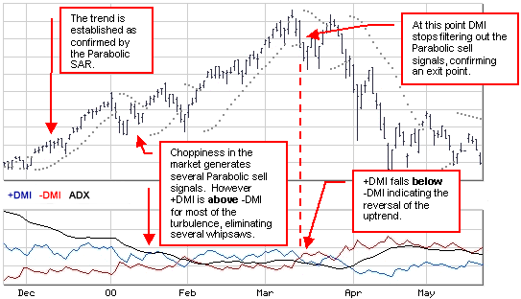
Refer to Welles Wilder's book New Concepts in Technical Trading Systems for a thorough discussion of Parabolic SAR.

Price Channel
The Price Channel or Donchian's Four Week Rule is a simple and effective trend following, channel breakout system.
Overview
Channel breakout systems were shown by research to be one of the top trading systems to generate significant profits
- Developed as the 4 Week Rule by Richard Donchian, originally for commodity trading
- Can be used on daily, weekly and monthly charts
Louis Lukac's research from 1975 to 1986 compared 23 trading systems. Moving averages and channel breaklouts came out as the top performers and Lukac suggested a channel breakout as the best starting point for technical trading. (Lukac, Louis; The Financial Review, November 1990).
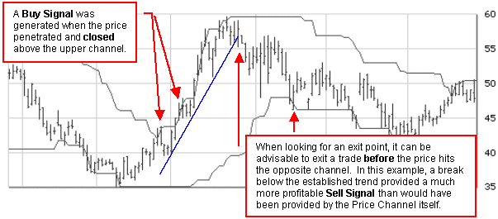

Interpretation
The Price Channel is a simple breakout system. As with all trend following systems, the Price Channel works well in up trends or down trends, but doesn't work well in a sideways channel. The signals derived from the Price Channel are based on the following basic rules:
- When the price is at its highest in a four week period, buy long and cover short positions
- When the price falls below the lows of a four week period, sell short and liquidate long positions
As a trend following system the Price Channel indicator is not meant to catch tops or bottoms. Trend traders may want to extend the period to eight weeks to wait for significant trend signals. Similarly, some traders shorten the time period to a more sensitive 1 or 2 weeks for liquidation purposes.
Signals
The following signals are offered by the Price Channel indicator:
- A buy signal is generated when prices penetrate and close above the upper channel.
- A sell signal is generated when prices penetrate and close below the lower channel.
These signals should, of course, be combined with the use of other indicators to provide confirmation. For example, a relatively simple, yet effective, approach to exiting a trade based on a price channel would be to watch for a break in the long-term trend.
Some Ideas for Applying Shorter Time Periods:
- Can be used to identify trend reversals
- When prices are trending sharply higher, shorten the time span for needed sensitivity
- Use a four week rule for entry and one or two weeks to signal exit points.
- A two week price breakout in the same direction as a moving average crossover signal, makes an exceptional filter on which to base a market decision
- A stop-loss could trail with a one week lag

Further Information
Also see Channels & Envelopes, Keltner Channels, and Bollinger Bands.

Interpretation
Andrews' Pitchfork is plotted on a price chart as follows:
- First, identify a significant reversal point (high or low) and this becomes Pt. A.
- Draw a line (shown in red) from this point to the next significant reversal point; at Pt. B.
- Then plot a line from a significant point early in the trend (Pt. C) bisecting the first line (in red) half way between Pts. A and B. This is the Median Line or "handle" of the Pitchfork.
- Now, draw two lines parallel to the Median Line, one starting from Pt. A and the other from Pt. B. These form the "tines" of the Pitchfork.
- Presto! Andrews' Pitchfork.
This is a quick introduction to the Pitchfork technique; Dr. Andrews' price study methods were typically much more complex than what I've shown here. He also counted waves using what he called the "0-3/4 pivot count rule" and the "5 count probability rule."

Signals
Watch for reversals when the price approaches or penetrates the lines of the Pitchfork. As with any trendline, the more often support or resistance is confirmed the more reliable the line can be considered. In the example above, the lower channel managed to contain most of the price activity - not perfectly - but enough to indicate that the channel was indeed providing important support and resistance.

Rate of Change
ROC is a momentum indicator that measures velocity and also leads the price action.

Overview
Rate of Change, ROC, can be very useful, because it is a leading indicator (ROC changes direction before the underlying price). ROC is sometimes also referred to as Price Rate of Change (PROC).
- ROC is a price momentum or velocity indicator.
- A rising ROC indicates a bullish increasing momentum
- A falling ROC indicates a bearish decreasing momentum
- ROC should always be used in conjunction with reversal signals on the price chart.
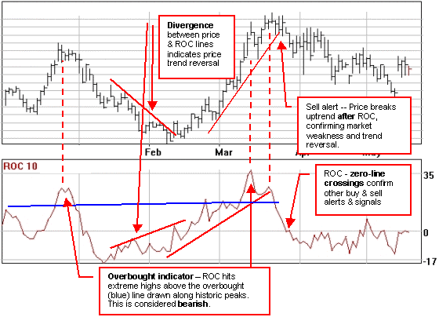
Whereas the Momentum indicator provides the difference between the current price and the price from a past period as a ratio, ROC displays the same information as a percentage on an open scale.. The zero-line, or equilibrium line, represents the level where the price is the same as the reading for the past period (e.g., 10 days for the 10-day ROC).

Interpretation
The ROC displays the amount prices have changed over the given time period as an oscillator. When the wave is above the equilibrium line, the market price is higher than it was at the start of the ROC time period. The higher the wave, the greater the change. When the wave sinks below the equilibrium line into a trough, the lower it goes, the lower the market is in comparison to the previous price. As the wave starts coming up from the bottom of a trough, in a rising ROC, this indicates expanding momentum (considered bullish). Conversely, a falling ROC is considered bearish.
Comparing the ROC's of different time spans improves the accuracy of the analysis. A 12 month period is usually the most reliable for long term trends and 3 or 6 month period works well for intermediate trends. As mentioned previously, a 10 or 12-day ROC is a good short term indicator, oscillating in a fairly regular cycle.
The lower the ROC, the more undersold the market and the more likely a recovery. Although the opposite may hold true in that the higher the ROC, the more overbought the market, both extremes can indicate the formation of a sideways channel.

Signals

Overbought/ Oversold Levels
Overbought and oversold lines can be drawn on the ROC chart, generally along previous highs and lows. There are no hard and fast rules about where these lines should be drawn. Like trend lines they should be drawn in response to the previous actions of the price and ROC indicator itself. Overbought levels can only be relied on to indicate a coming market reversal when a bull market has matured, or during bearish phases.
You can filter out a many premature buy and sell signals by waiting for:
- the ROC to come back through the overbought or oversold line the second time, and
- a confirmation of a trend reversal from the price itself.

Divergences
Divergences can provide warnings or alerts of weaknesses in market trends, but do not represent actual buy or sell signals. It is essential to wait for a confirmation from the price itself that the overall trend has reversed.

Zero-line crossings
Although the long-term price trend is still the overriding consideration, a crossing upward through the zero line can confirm a buy signal and a crossing downward through the zero line, a sell signal.

Trendline Violations
The trendlines on the ROC chart are broken sooner than those on the price chart. The value of the momentum indicators is that it turns sooner than the market itself, making it a leading indicator.

Relative Strength Index
The Relative Strength Index (RSI) can provide an early warning of an opportunity to buy or sell.

Overview
- The RSI is a momentum indicator, or oscillator, that measures the relative internal strength of a market (not against another market or index).
- As with all oscillators, RSI can provide early warning signals but should be used in conjunction with other indicators.
- Divergences are the most important signal provided by RSI.
The Relative Strength Index (RSI) is a popular oscillator developed by Welles Wilder, Jr (see his book, New Concepts in Technical Trading Systems). RSI measures the relative changes between higher and lower closing prices, and provides an indication of overbought and oversold conditions.
The term "Relative Strength" is slightly misleading and often causes some confusion. Relative strength generally means a comparison between two different markets or indices. RSI, on the other hand, looks at the internal strength of a single market.
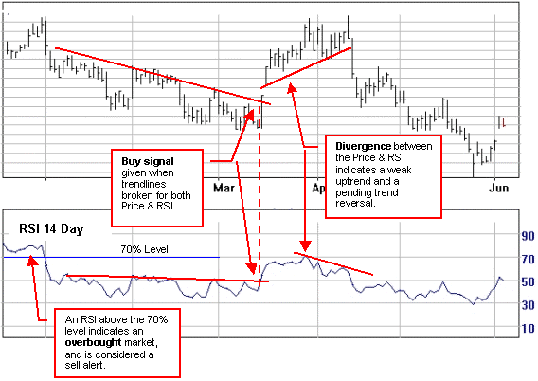

Interpretation
RSI is plotted on a vertical scale of 0 to 100. The 70% and 30% levels are used as warning signals. An RSI above 70% is considered overbought and below 30% is considered oversold. The 80% and 20% levels are preferred by some traders. The significance depends upon the time frame being considered. An overbought reading in a 9-day RSI is not nearly as significant as an RSI for a 12-month period.
An overbought or oversold condition merely indicates that there is a high probability of a counter reaction. It is an indication that there may be an opportunity to buy or sell, but does not provide the final signal. RSI signals should always be used in conjunction with trend-reversal signals offered by the price itself.
RSI can be plotted for any time span. Wilder originally recommended using a 14-day RSI. Since then, the 9, 10 and 25-day RSIs have also become popular. The shorter the time period, the more sensitive the oscillator becomes. If the user is trading short-term moves, the time period can be shortened. Lengthening the time period makes the oscillator smoother and narrower in amplitude.
In using RSI, a crossover above the 70% level is a warning signal to prepare to sell and, conversely, when the RSI falls below 30% you have a notice to prepare to buy. The actual buy and sell signals are given when the RSI reverses (see below). RSI crossings through the 50% level are also used as buy and sell signals by some traders.

Signals

Tops & Bottoms, Failure Swings, Divergence
Traders watch for double tops or what Wilder referred to as "failure swings." If the RSI makes a double top formation, with the first top above 70% and the second top below the first, you get a sell signal when the RSI falls below the level of the dip. Conversely, a double bottom at or below 30% (with the first low below 30% and the second at or above the same level) gives you a buy signal when the RSI breaks above the previous peak.
These failure swings can lead to divergences between the price action and the RSI. For example, a divergence occurs when a market makes a new high or low, but the RSI fails to set a matching new high or low. A divergence can be an indication of an impending reversal. In Wilder's opinion, divergences are the most important signal provided by RSI.
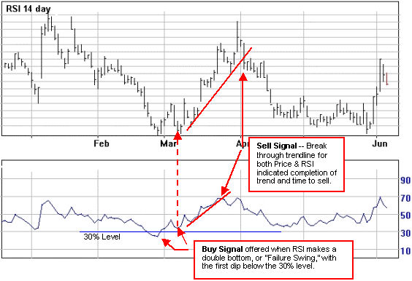

Trendlines
RSI trendlines can provide good signals, particularly when used in conjunction with price patterns. When both price and RSI trendlines are violated within a short period you could have an important buy or sell signal.

Stochastic Oscillator
The stochastic indicator can help determine when a market is overbought or oversold.

Overview
The stochastic indicator is:
- a momentum oscillator that can warn of strength or weakness in the market, often well ahead of the final turning point.
- based on the assumption that when a stock is rising it tends to close near the high and when a stock is falling it tends to close near its lows.
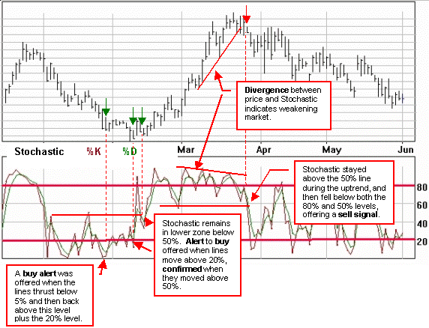
The original stochastic oscillator, developed by Dr. George Lane, is plotted as two lines called %K, a fast line and %D, a slow line.
- %K line is more sensitive than %D
- %D line is a moving average of %K.
- %D line triggers the trading signals.
Although this sounds complex, it is similar to the plotting of moving averages. Think of %K as a fast moving average and %D as a slow moving average. The lines are plotted on a 1 to 100-scale. "Trigger" lines are normally drawn on stochastics charts at the 80% and 20% levels. A signal is generated when these lines are crossed. The zones above and below these two lines can be referred to as the stochastic bands.

Slow Stochastics
The original stochastic is sometimes referred to as the "fast" stochastic to differentiate it from the "slow" stochastic. Some traders feel the fast stochastic %K line is too sensitive and, to improve their analysis, they replace the original %D line with a new slow %K line. The new slow %D line formula is then calculated from the new %K line. The result is a pair of smoothed oscillators that some traders believe provide more accurate signals.

Interpretation
The 80% value is used as an overbought warning signal, and the 20% is used as an oversold warning signal. The signals are most reliable if you wait until the %K and %D lines turn upward below 5% before buying, and the lines turn downward above 95% before selling.
An overbought or oversold level indicates that a market may be vulnerable to a retracement
- These signals are particularly important with monthly charts. Buying into a market with an overbought %K or selling into one that is oversold may involve above-average risk, particularly if the market is pressing against previous levels of support or resistance.

Signals
The Stochastic Oscillator generates signals in three main ways:
- Extreme values when the 20% and 80% trigger lines are crossed. Buy when the stochastic falls below 20% and then rises above that level. Sell when the stochastic rises above 80% and then falls below that level.
The pattern of the stochastic is also important; when it stays below 40-50% for a period and then swings above, the market is shifting from overbought and offering a buy signal. And vice versa when it stays above 50-60% for a period of time.
- Crossovers between the %D and %K lines. Buy when the %K line rises above the %D line and sell when the %K line falls below the %D line. Beware of short-term crossovers. The preferred crossover is when the %K line intersects after the peak of the %D line (right-hand crossover). Crossovers often provide choppy signals that need to be filtered through the use of other indicators.
- Divergences between the stochastic and the underlying price. For example, if prices are making a series of new highs and the stochastic is trending lower, you may have a warning signal of weakness in the market.

Ultimate Oscillator
The Ultimate Oscillator is sensitive to buying and selling pressure and offers reliable signals.
- Larry Williams developed the Ultimate Oscillator to address the problems experienced with most oscillators when used over different lengths of time.
- Signals are based on divergence and a breakout in the Oscillator's trend, as well as overbought and oversold levels.
Williams noted that the value of oscillators can vary greatly depending on the number of time periods used during the calculation. The Ultimate Oscillator, therefore, uses weighted sums of three oscillators which represent short, intermediate, and long term market cycles (7, 14, & 28-period). It is plotted as a single line on a vertical scale of 0 to 100.
The three oscillators are based on Williams's definitions of buying and selling "pressure."
Williams recommends that you initiate a trade following a divergence and a breakout in the Ultimate Oscillator's trend.
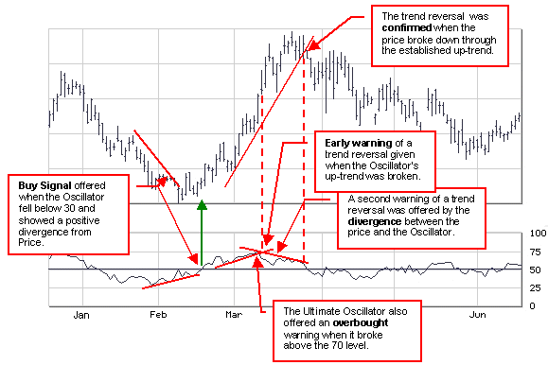

Signals
A Buy signal is offered when:
- A positive or bullish divergence occurs between the Oscillator and the price.
- The Oscillator falls below 30 and then rises above the previous high established during the divergence (the actual buy signal).
A Sell Signal is offered when:
- A negative or bearish divergence occurs between the Oscillator and the price.
- The Oscillator rises above 70 and then falls below the previous low established during the divergence (the actual sell signal).
Closing existing positions:
- Close long positions when the oscillator exceeds 70.
- Close short positions when the oscillator goes below 30.
Please remember that, as with most indicators, these signals should be confirmed by other indicators before being acted upon.

William's % R
Williams %R has proven very useful for anticipating market reversals.

Overview
- Williams %R is a momentum indicator
- identifies overbought or oversold markets.
- It is plotted on an inverted 0 to 100 scale.
This oscillator, a version of the stochastics oscillator, was developed by Larry Williams.
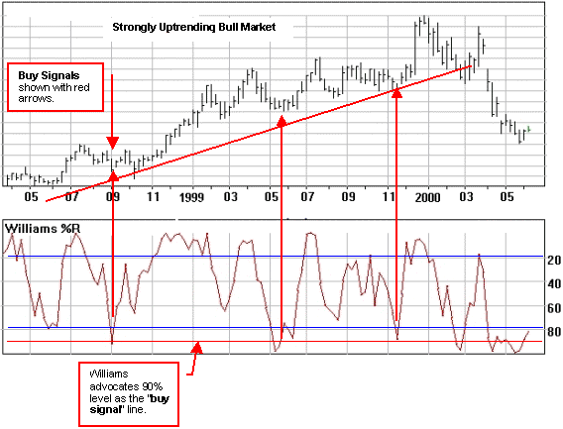
In the example above a strongly uptrending market it shown with the Williams %R indicator plotted below. The primary buy signals are shown in red. More cautious investors wait for the %R to form a definite low below 90% and then bounce back through this level before acting on the buy signals.

Interpretation
Mr. Williams indicates that the essence of his trading system is based on interpreting readings of %R. He states that, "Generally speaking, readings below 95% give a buy indication - during bull markets. A reading above 10% gives a sell signal during bear markets." He goes on to say that "the %R index will not work if you insist on acting on the buy signals during a bear market." He emphasizes strongly the need to isolate the dominant trend - whether it is a bull or bear trend. Then he tracks price movements with %R and waits for the signals. (See his book, "How I made One Million Dollars... Last Year... Trading Commodities" by Larry R. Williams.)
To determine the long term trend for commodity or futures markets, Mr. Williams advocates the use of a 10-week moving average. The indicator is now popular in most markets and has proven itself useful with stocks.
Like other momentum indicators, Williams %R is not very useful in a sideways market, or trading range. The market needs to be trending up or down for the signals to be reliable.

Signals
Mr. Williams bases his system largely on the use of the following two signals (once again notice that the signal is reliant on the direction of the underlying long-term trend):
- Buy when %R hits 90% to 100% and the trend is up.
- Sell when %R hits 10% to 0% and the trend is down.
Some traders use readings below 80% to indicate oversold markets and readings above 20% to indicate overbought markets. These levels can also be used as early warning signals.
In a blow-off market, where prices have undergone a very steep rise, Mr. Williams suggests waiting before responding to %R. For example, he suggests acting on buy signals (assuming the long term trend is up) only after:
1. %R has hit 100%,
2. Five trading days have passed since the 100% reading was hit, and
3. %R again falls below 95%.
Mr. Williams assures us that not all signals will be correct; there are no perfect indices. "Yet," he continues, "%R remains the best timing tool I have ever used for determining overbought and oversold markets."
Williams %R has proven very useful in anticipating market reversals. The indicator almost always forms a peak and turns down a few days before the price peaks and turns down. And vice versa for bottoming markets.

On Balance Volume
On Balance Volume can be used to either confirm the current price trend or warn of a possible reversal.

Overview
- It is the trend of the OBV line that is important, not the actual numbers themselves.
- OBV is a momentum indicator that helps quantify buying or selling pressure.
- OBV changes often precede price changes.
On Balance Volume was developed by Joe Granville. See his book New Strategy of Daily Stock Market Timing for Maximum Profits for more detailed information.
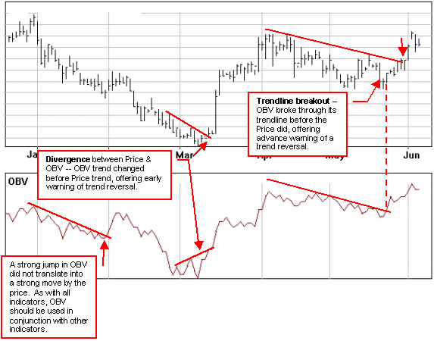

Interpretation
It is the direction of the OBV line (its trend) that is important and not the actual numbers themselves. The actual OBV values will differ depending on how far back you chart.
The OBV line should follow in the same direction as the price trend. If prices are in an uptrend, the OBV line should do the same. If prices are trending lower, the OBV line should do the same. If the OBV line shows a divergence from the price trend, you have a warning of a possible trend reversal. OBV changes usually precede price changes.
OBV shows if volume is flowing into or out of a security, or the buying and selling pressure. When there's strong and increasing buying pressure, the price is almost certain to continue going up. The theory is that money from knowledgeable traders, or "smart money," can be seen flowing into the security by a rising OBV. When the public then moves into the security, both the security and the OBV will surge ahead.
Also watch for OBV line breakouts, when the OBV breaks its established trend (see Breakout Signals). Since OBV breakouts normally precede price breakouts, an OBV upside breakout is a buy signal. Likewise, an OBV downside breakout is a sell signal.
On Balance Volume is well-suited to trading short-term cycles, however, Granville advises that investors must act quickly and decisively if they wish to profit from short-term OBV analysis. Traders also recommend that the daily, weekly and monthly charts should be consulted for OBV to confirm the buy and sell signals. Signals OBV offers the following signals:
- Divergence between price and the OBV line
- Trendline breakouts that forewarn of impending price trend reversals.
- MA crossovers, when the OBV is plotted with its Moving Average.
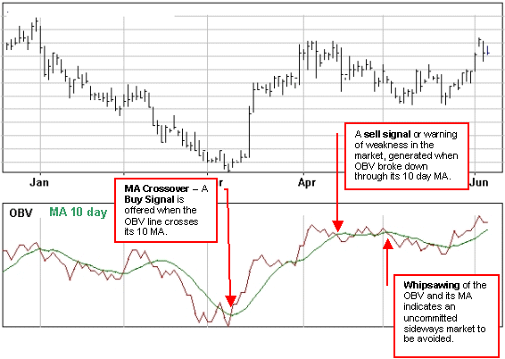

Drawbacks
One of the weaknesses of the OBV indicator is that an entire day's volume is assigned a plus or minus value. Many experimental variations of OBV have been developed in trying to discover a more accurate measure for the flow of volume. One of the more advanced, and useful, is the Money Flow Index
Average True Range
Average True Range (ATR) is a volatility indicator. It is also used as part of other trading systems such as Starc Bands and Keltner Channels.

Overview
- ATR provides a measure of volatility.
- ATR is calculated as the moving average of true price ranges over a given period.
- Developed by Welles Wilder and first described in his 1978 book New Concepts in Technical Trading Systems
Interpretation Average True Range is a moving average of the True Range over "X" periods, usually 14-days. True Range is the greatest difference from the following choices:
- Today's high and today's low.
- Today's high and yesterday's close, or
- Today's low and yesterday's close.
True range is always a positive number (negative numbers from the calculation above are to be ignored).
Major tops are typically accompanied by high volatility during the blow-off phase of a market, as investors become more and more nervous and ready to take profits. Major bottoms are usually calmer, with low volatility, as the hopes for quick profits have faded.

Signals
High ATR values are often correlated with high volatility as prices bottom and there is a sell off.
Low ATR values are often correlated with low volatility as prices stabilize or move into a sideways channel prior to a possible breakout.

Further Information
Also see Keltner Channels.

Breakout Signals
A breakout in price through a long established trend line is always significant.
Overview
- When a price breaks out of a stable, established range, for whatever reason, the odds are high that it will continue to move in the same direction
- The longer the trend, the greater the potential move
- An upward surge in trading activity, or volume, confirms the validity of the breakout.
- When the volume does not show a significant increase on the upside price breakout, the price pattern should be questioned.
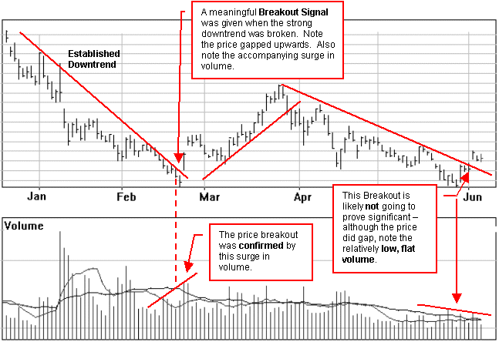
Interpretation
The breaking of an important trendline is often the first sign of an impending change in trend, which is only sometimes a trend reversal. The breaking of a major upward trendline might signal the beginning of a sideways price pattern, which would be identified as a reversal or consolidation type later.
The stronger the trendline broken the more significant. Historically we know that if a strong or "well-tested" trendline is broken and the price moves out of an established range something important has happened to the psychology of the marketplace. We may not know what it is; it will probably be a combination of influences or events. But, whatever the reasons, any pull strong enough to break a long term trendline and carry the price into new ground is usually strong enough to continue pulling the market in the new direction to establish a new trendline.
The odds that a market will continue in the direction of a breakout are high but, of course, there are no guarantees. Remember, this is not a golden rule; it is a pattern which has been repeated many, many times in the past and will be repeated many more times in the future. It gives us something tangible to look for when considering the hundreds and thousands of potential trades we could enter into.
Breakout Validity
Not every move out of the price pattern constitutes a valid signal of a trend reversal, or resumption if the price is in a narrow trading range. It's helpful to establish valid criteria to minimize the possibility of misinterpreting moves such as whipsaws. A wait for a 3 percent penetration of the boundaries is traditionally necessary before determining that the breakout is valid. The resulting signals are less timely, but a considerable number of misleading moves are removed.
However, many short-term price movements barely exceed 3 percent in total. In short term trades it will be difficult to make a profit if you wait for a 3 percent move to buy, and an additional 3 percent decline for a breakdown to sell. The 3 percent rate works well for longer-term price movements where the fluctuations are much greater. Deciding whether a breakout is valid or not depends on the type of trend being monitored, volume, momentum characteristics and your own experience.
An upward surge in trading activity, or volume, confirms the validity of the breakout. A low volume breakout is suspicious and should be disregarded. Increasing volume is not as essential for a valid signal with downside breakouts, as it is for an upside breakout. Prices will often reverse and put on a small recovery, following the downside breakout. This price increase is regularly accompanied by declining volume.
Further Information
Also see Trendlines, Dow Theory, Triangles, and Tops & Bottoms

Dow Theory
Dow Theory At a Glance
Overview
Dow Theory is based on the philosophy that the market prices reflect every significant factor that affects supply and demand - volume of trade, fluctuations in exchange rates, commodity prices, bank rates, and so on. In other words, the daily closing price reflects the psychology of all players involved in a particular marketplace - or the combined judgment of all market participants.
The goal of the theory is to determine changes in the major trends or movements of the market. Markets tend to move in the direction of a trend once it becomes established, until it demonstrates a reversal. Dow theory is interested in the direction of a trend and doesn't offer any forecasting ability for determining the ultimate duration of a trend.
Much of today's technical analysis is based on Dow's original "trend following' system -
- Classification of a trend
- Principles of confirmation or divergence
- Use of volume to confirm trends
- Use of percentage retracement
- Recognition of major bull and bear markets
- Signaling the large central section of important market moves
- Dow theory has been successful in identifying 68% the major trends over the years
The three trends are:
- Uptrend: successively higher peaks (highs) and higher troughs (lows)
- Downtrend: successively lower peaks and troughs
- Sideways Channel: peaks and troughs don't successively rise or fall
Each market trend has three parts compared to tides, waves and ripples.
- The primary (major) trend or tide is a long term trend lasting from a year to several years
- The secondary trend (or mid-term trend) or wave lasts three weeks to three months and represents corrections of one third to two thirds of the previous movement - most often fifty percent of the movement.
- The minor trends (short-term trends) or insignificant ripples last less than three weeks and represent fluctuations in the secondary trend.
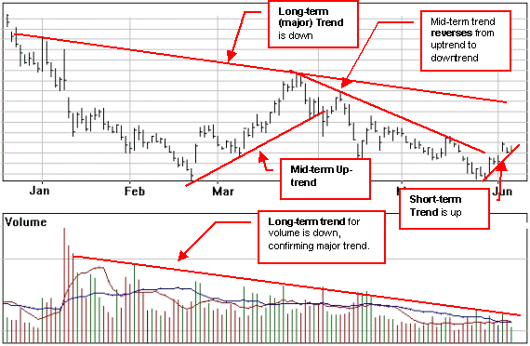
The major trend has three phases:
- Accumulation phase: knowledgeable investors buy issues with good potential
- Public Participation phase: Prices increasing rapidly and bullish markets are reported
- Distribution phase: Astute investors sell first, thereby leading the public
A Major or Long-term Stock Market Trend:
- Must be confirmed by the Dow Averages, calculated on closing prices only, not the daily high or low (this provides the overall stock market trend)
- Should have volume increase/decrease in the direction of the trend
- Stays in effect until it gives definite reversal signals
Shortcomings of the Dow Theory:
- The major criticism of the Dow Theory is its slowness: It misses about 25% of a move before giving a signal, primarily because it is a trend following system designed to identify existing trends.
Also see trendlines, tops & bottoms, and triangles.

Fibonacci arcs & retracements
Fibonacci Arcs & Retracements help anticipate support and resistance levels along with price targets.
Overview
After making long sustained moves in one direction, many markets retrace a part of the move before continuing on further. The Fibonacci indicator, popularized by Ralph Nelson Elliot, is used to try and forecast potential support levels and price targets, based on the height of the overall move and any wave patterns.
For example, if a stock increased from $5 to $10 and then slipped back 50%, this retracement would take it to $7.50 before it continued upwards again.
This indicator uses mathematical ratios discovered by Leonardo Fibonacci's in the 12th century. The Fibonacci summation series is 1, 1, 2, 3, 5, 8, 13, 21, 34, 55, 89, 144… and so on to infinity. Interestingly, these numbers have the following constant relationships:
- The sum of any two consecutive numbers equals the next higher number.
- The ratio between any number and the next higher number approaches 0.618 after the first four calculations.
- The ratio between any number and the next lower number is approximately 1.618 (the inverse of 0.618).
The number 1.618 is commonly referred to as the Golden Mean or the Golden Section. The real value of this number series is that it is "the most important mathematical presentation of natural phenomena ever discovered" (R. Fischer). It keeps popping up in everything from the proportions of the Egyptian pyramids… the number of florets in flower heads…the double helix of the DNA molecule… to the logarithmic spiral of the nautilus shell.
(The well-known Elliot Wave Principle is also based on the application of Fibonacci numbers to the waves evident in any price chart.)
Interpretation
The most commonly used numbers in this analysis are 61.8% (usually rounded off to 62%), 38% and 50%. This means that, in a strong trend, the minimum retracement is usually close to the 38% level and may go as far as the 62% level.
Constance Brown, a well known technical analyst, has written, "If the market has shown respect in the past to a Fibonacci grid drawn on the chart, the chances are much higher that it will also respect those levels in the future market action."
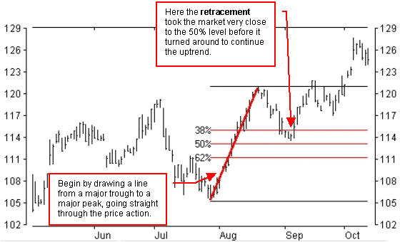
Fibonacci Retracements
- Fibonacci Retracements are based on a trendline drawn between a significant trough and peak.
- If the trend is rising, the retracement lines will descend from 100% to 0%
- If the trendline is falling, the retracement lines will ascend from 0% to 100%
- Horizontal lines are drawn at the common Fibonacci levels of 38%, 50%, & 62%
- As the price retraces, support and resistance often occur at or near the Fibonacci Retracement levels.
Fibonacci Arcs Fibonacci arcs can be added to the same chart, or they can be charted alone. The arcs are drawn centered on the last peak or trough, crossing the original trendline at the points where the retracement lines intersect. The price will tend to "react" to both the arcs and the retracement levels, as they provide support and resistance.
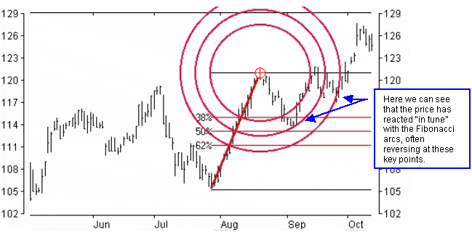
Price Targets
More advanced studies can also be undertaken, based on the Fibonacci numbers, to develop price targets. One such approach is to add a second copy of the original Fibonacci grid above or below the first (depending on which way the market is trending). This will give you potential price targets based on adding a new set of 38%, 50% and 62% lines.
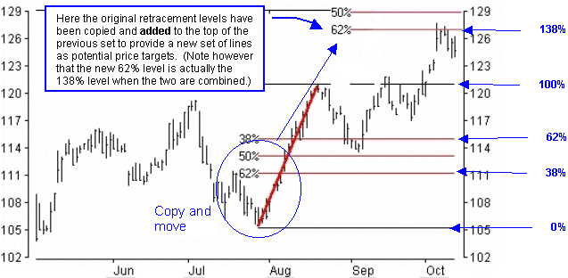
If you would like to read more about Fibonacci price projections see Constance Brown's book, Technical Analysis for the Trading Professional and Joe DiNapoli's Trading with DiNapoli Levels.
Further Information
Also see the Elliot Wave Theory. Much more advanced studies are available when the Fibonacci numbers are combined with the Elliot Wave count
MACD Histogram
The MACD Histogram is useful for anticipating changes in trend.

Overview
- The MACD Histogram (MACD-H) consists of vertical bars showing the difference between the MACD line and its signal line
- A change in the MACD-H will usually precede any changes in MACD
- Signals are generated by direction, zero line crossovers and divergence from MACD
- As an indicator of an indicator, MACD-H should be compared with MACD rather than with the price action of the underlying market. MACD-H is used with MACD as a complementary indicator.
Thomas Aspray found that MACD signals often lagged important market moves, especially when applied to weekly charts. He first experimented with changing the moving averages and found that shorter moving averages did indeed speed up the signals. However, he was looking for a means to anticipate MACD crossovers and came up with the MACD Histogram.
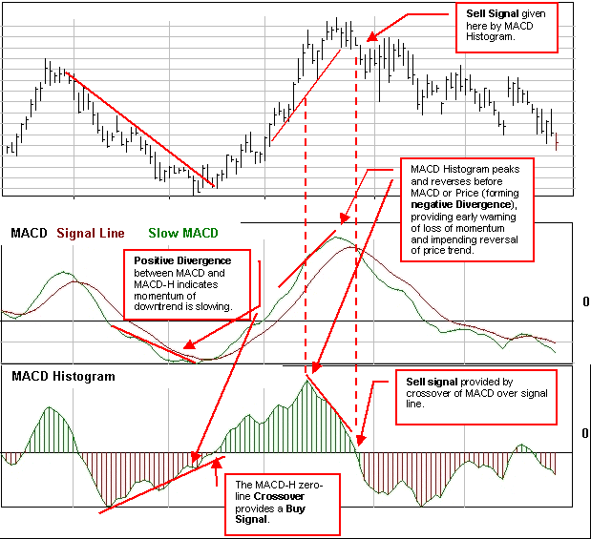

Interpretation
The MACD Histogram represents the difference between MACD and it's signal line (usually the 9-day Exponential Moving Average (EMA) of the MACD). Whenever MACD crosses the signal line, MACD-H crosses the zero line.
- If the MACD line is above the signal line, the histogram is positive, and the bars are drawn above the zero line.
- If the MACD line is below the signal line, histogram is negative, and the bars are drawn below the zero line.
Sharp increases in the MACD-H indicate that MACD is rising faster than its 9-day EMA and upward momentum is strengthening. Sharp declines in the MACD-H indicate that MACD is falling faster than its moving average and downward momentum is increasing.
Divergences between MACD and MACD-H are the main tool used to anticipate crossovers. A positive divergence in the MACD-H indicates that MACD is strengthening and could be on the verge of a bullish moving average crossover. A negative divergence in the MACD-H indicates that MACD is weakening and can act to foreshadow a bearish moving average crossover in MACD.

Signals
The main signal generated by the MACD-Histogram is a divergence from MACD followed by a zero-line crossover.
- A bullish signal is generated when a positive divergence forms and there is an upward zero line crossover.
- A bearish signal is generated when there is a negative divergence and a downward zero line crossover.
In Technical Analysis of the Financial Markets, John Murphy states that the real value of the MACD-H is spotting when the spread between the two lines is widening or narrowing. When the histogram is above its zero line (positive) but starts to fall, the uptrend is weakening. Conversely, when the histogram is below its zero line (negative) and starts to rise, the downtrend is losing momentum. These turns of the histogram provide early warnings that the current trend is losing momentum, and the buy or sell signal is given when the histogram crosses the zero line.
Murphy also advocates a two-tiered approach in order to avoid making trades against the major trend. The weekly MACD-H can be used to generate long-term signals. Then only short-term signals that agree with the major trend are used.
- If the long-term trend is up, only positive divergences with upward zero line crossovers are considered valid for the MACD-H.
- If the long-term trend is down, only negative divergences with downward zero line crossovers are considered valid.
Used this way, the weekly signals become trend filters for daily signals. This prevents using daily signals to trade against the overall trend.

Price and Volume trend
The Price and Volume Trend (PVT) is a cumulative total of volume adjusted according to relative changes in closing prices. It is similar to On Balance Volume (OBV).

Overview
PVT is calculated by adding a percentage of the volume when prices close up and subtracting a percentage of volume when the prices close down. (OBV adds all volume when prices close higher and subtracts all volume when prices close lower.) The amount of volume added or subtracted to the PVT is relative to the amount that prices rose or fell compared to the previous day's close (see note on calculation below).
- When the price changes by a small percentage, PVT adds only a small portion of volume to the indicator
- When the price changes by a large percentage. PVT adds a large portion of volume to the indicator
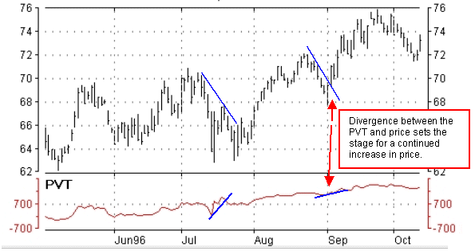

Interpretation
- When the PVT falls money is flowing out of this market (falling prices accompanied by increased volume).
- When the PVT rises money is flowing into this market (prices and volume are increasing together).
PVT is a leading indicator for future price movements. Although interpretation of PVT is similar to the OBV and the Accumulation/Distribution indicators, PVT more accurately demonstrates the flow of money. PVT adds only a proportional amount of volume to the indicator, whereas OBV adds the same amount of volume not considering whether the market closes up a fraction of a point or triples in price.
- Rising PVT means new money, sometimes referred to as "smart money, " is flowing into the marketplace. The result will be that the present trend will continue. Accelerating PVT rise indicates that "the masses" are joining the new price trend.
- If the PVT then levels off, it is often an early warning that the trend is finishing.
- Declining PVT indicates that the smart money is liquidating.
- If the PVT moves sideways or falls while the price is rising, the increase in price is not confirmed and a market top or bottom may be indicated.

Signals
The main signal offered by the PVT indicator is divergence from price.
In the example charted above, bullish divergence was seen on two separate occasions -- with the PVT trending higher while prices trended lower -- followed by strong price increases in both cases.

Calculation
PVT is calculated by multiplying the day's volume by the percentage change from yesterday's close and adding this value to a cumulative total. For example, if a stock closed up 0.5% and volume was 10,000 shares, you would add 50 (i.e., 0.005 X 10,000 = 50) to the PVT. If the stock had closed down 0.5 %, you would subtract 50 from the PVT.

Reversal Patterns
(Tops And Bottoms)
Reversal patterns, or tops and bottoms, signify a fundamental change in the long term trend.

Overview
- Tops are usually less stable and shorter than bottoms.
- Bottoms usually have smaller price variations and are slower to establish.
- Volume is usually more important on the upside.
- Confirmation of a top or bottom is in a double top or bottom (or a short channel.)
The most popular Reversal Patterns include: head and shoulders, double tops and bottoms, triple tops and bottoms, and V-formations.

Interpretation & Signals

Head & Shoulders
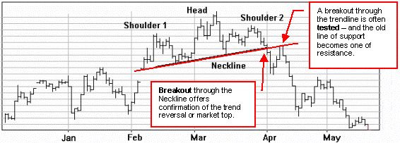
The well known head and shoulders pattern is formed by three peaks; the center peak, or head, is slightly higher than two lower, and not necessarily symmetrical, shoulders. The line joining the bottoms of the two shoulders is called the neckline. Due to fluctuations, the neckline is rarely symmetrical or perfectly horizontal.
The pattern isn't complete until the neckline is broken. It is often good to wait for confirmation - for example, two successive closes below the neckline. Remember, markets often bounce back to the Neckline after the breakout and this becomes a new level of resistance.
Volume should be assessed to confirm the validity of these patterns. Volume is normally heaviest during the formation of the left shoulder and also tends to be quite heavy as prices approach the peak. The real confirmation of a developing Head and Shoulders pattern comes with the formation of the right shoulder, which is invariably accompanied by distinctly lower volume.
Some traders use the distance between the neckline and the top of the head to project a "price objective." The price objective is determined by measuring from is the top of the head to the neckline, and using this distance from the breakout point downwards.
An Inverted Head and Shoulders pattern is a mirror image of the Head & Shoulders pattern (forming a market bottom).

Double Tops
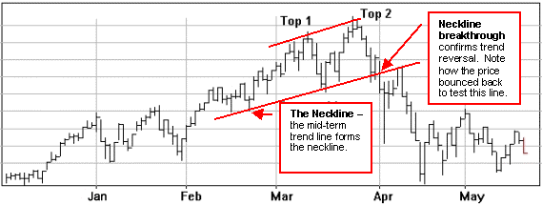
Double Tops are another reliable and frequently used reversal pattern. This pattern consists of two tops of approximately equal height. A line is drawn below and parallel to the resistance line that connects the two tops. The neckline is a strong support for price level but eventually fails.
As with a Head and Shoulders, after the two rallies and their respective reversals are completed the double tops is confirmed only when the neckline is broken. The support line then becomes a resistance line, which often holds a market rebound.
A Double Bottom pattern is a mirror image of a double top pattern: The average height of the bottoms gives a good indication of the price objective.

Triple Top
A tnple top is a cross between a head and shoulders and double top. This formation consists of three tops of approximately equal height. A line is drawn below and parallel to the resistance line that connects the three tops. The neckline is a strong support for price level but eventually fails. The support line then becomes a resistance line, which usually holds any market rebound.

Triple Bottom
A triple bottom pattern is a cross between an inverted head and shoulders and double bottom pattern.

V- Pattern
The V pattern is an unusual pattern in that a sharp trend switches from one direction to the other without warning and with high volume at or just after the turn around.
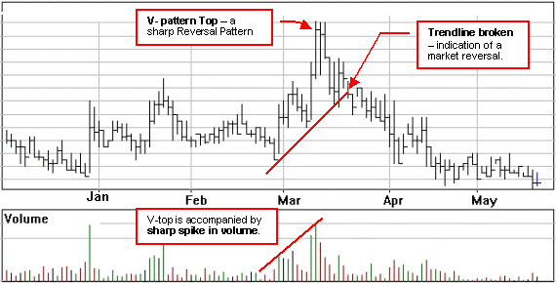

Further points
Trend reversals offer some of the most important opportunities for entering a market with a good profit potential. They usually represent fundamental changes in the underlying character of a particular market and often go on to yield big moves.
However, a market top or bottom is often difficult to identify. It is even more difficult to choose appropriate entry and exit points. One problem is distinguishing between an actual change in trend or merely a congestive phase in the middle of a move. It is usually advisable to wait for prices to actually confirm a trend reversal by developing one of these well-tested and reliable reversal patterns. The actual buy or sell signals are based on a breakout in the direction of the new trend.
Here are some general observations about Reversal patterns:
- A breakout through a trend line is used in conjunction with a price pattern to yield signals in terms of both price level and timing.
- The longer the time required to form a pattern and the greater the price fluctuations within it, the more substantial the coming price movement is likely to be. The time frame is normally from several days to several months - intraday patterns are not considered reliable.

Swing Index
This momentum indicator is used primarily as a component of the Accumulative Swing Index.

Overview
Welles Wilder developed the Swing Index to provide a line "which cuts through the maze of high, low and close prices and indicates the real strength and direction of the market." (For a detailed description refer to Wilder's book New Concepts in Technical Trading Systems.)
The Swing Index is used primarily as a basis for Wilder's Accumulative Swing Index (ASI) indicator.
Mr. Wilder summarizes the significance of the Swing Index as follows:
- Swing Index gives one numerical value that always falls between +100 and -100, while incorporating current and previous opening and closing prices and true range in its complex calculation.
- Swing Index provides a line which gives definitive short-term swing points.
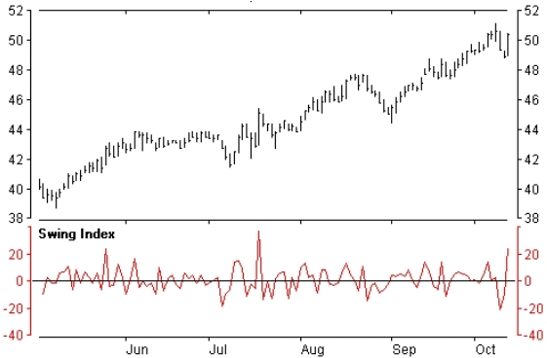

Interpretation
The Swing Index alone doesn't provide much in the way of signals. It should be used in conjunction with the Accumulative Swing Index.

Speed Resistance Lines
Speed Resistance, or Speedlines, are a combination of percentage retracements and trend lines that change with the trend.
Overview
Speedlines, developed by Edson Gould, are a variation on the idea of dividing the trend into thirds. The main difference from the percentage retracement is that speedlines measure the rate of ascent or descent - or "speed" - of a trend as it develops.
In an uptrend the speedlines are drawn by:
- Drawing a line vertically from the base to the highest peak (shown as a blue line)
- dividing this vertical line into thirds
- drawing speedlines (shown as red lines) from the beginning of the trend through the 1/3 and 2/3 points
- The upper line is often referred to as the 2/3 speed line and the lower line as the 1/3 speedline
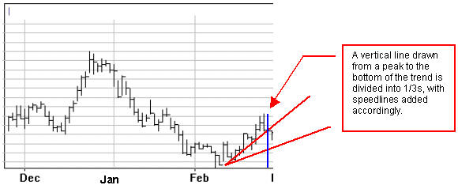
As the trend develops and new peaks (or valleys in the case of a downtrend) are formed the vertical line is redrawn and new speedlines are added.
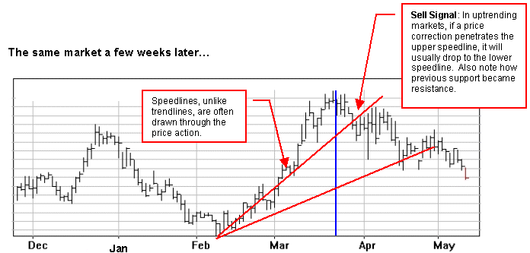
Signals
Uptrend: If a correction is underway in an uptrend, the price will usually stop at the upper speedline. If the price penetrates the upper speedline, however, this is often a good indication of a trend reversal and can be used a sell signal.
Downtrend: In a downtrend, a penetration through the lower speedline signals a likely rally to the upper line; and if the upper line is broken this usually indicates a continued rally.

Sequential® Analysis
An indicator designed to identify market exhaustion using price patterns. It can help to anticipate trend reversals.

Overview
- Developed and trade marked by Tom DeMark, this indicator helps identify market exhaustion (based on the premise that price reversals are the result of market exhaustion).

Interpretation
Sequential Analysis involves a three step process of counting the daily bars on a bar chart:
- Set Up:
  - Buy set up: count nine consecutive daily price closes which are lower than the close four days earlier.
  - Sell set up: count nine consecutive daily price closes which are higher than the close four days earlier.
- Requisite filter (Intersection):
This step is designed to filter-out false expectations of a reversal when the trend is strong.
  - To confirm a buy set up the highs of day 8 or 9 must intersect the lows of three or four days previous.
  - To confirm a sell set up the lows of day 8 or 9 must intersect the highs of three or four days previous.
- Countdown:
  - A buy set up is 13 closes lower than or equal to the close 2 periods earlier (unlikely that these will be consecutive)
  - A sell set up is 13 closes higher than or equal to the close 2 periods earlier (unlikely to be consecutive).

Signals
Only after the entire three-step process has unfolded, would you enter the market.

TD ARCS
Developed and trade marked by Tom DeMark, TD Arcs combine a percentage retracement with the time period.
Downtrend (Upside Arc)
- Connect the most recent low to the previous highest peak.
- Draw the Fibonacci retracement levels (38.2% and 61.8%) on this line, pivoting at the recent low price
Uptrend (Downside Arc)
- Connect recent high to previous lowest low
- Draw the Fibonacci retracement levels on this line, pivoting at the recent high price
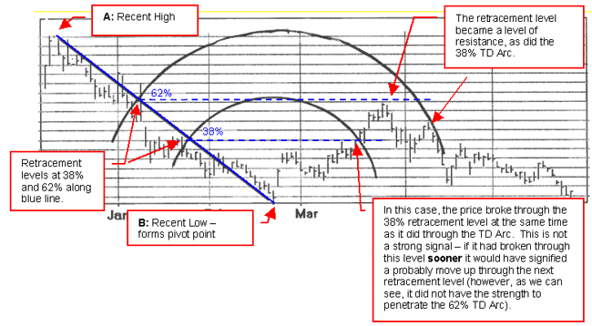
Interpretation
- Find the highest high (A) between the current low (B) and the last time the price exceeded this low, draw a line connecting A and B.
- Mark the .382 and .618 Fibonacci percentage reversal figures on this line and swing forward. TD Arcs are the retracement levels marked on the straight line
- A time filter is used to test the retracement strength.
Signals
If the price retraces 38 percentage points of the previous move in less than 38% of the period that generated the last move, the price has a greater chance of retracing further to the 62% level.
The key to TD Arcs is the speed with which the first retracement level is reached and broken (or not) by the price. If the 38% level is reached and broken before the 38% Arc, there's a strong tendency for the momentum to carry the price up through the next retracement level at 62%. As the example above demonstrates, however, if this doesn't occur quickly enough (before the price reaches the 38% Arc) the momentum tends to lag, the retracement becomes exhausted, and the market once again follows the overall long-term trend.
Further Information
See also Fibonacci arcs.

Trendlines
Trendlines illustrate the direction of the market movement and provide a primary consideration in any analysis.
Overview
- Uptrends consist of a series of successively higher highs and lows.
- Downtrends consist of a series of successively lower highs and lows.
The first consideration when looking at any market is the direction of the long term trend (with the exception of day traders).
Prices can only go in three directions; up, down, and sideways. A long line of past price ranges together gives you a pattern. There will be plenty of dips and bumps along the line but you should still be able to discern a general direction up, down, or sideways. We can help spot this direction or trend by drawing in "trendlines".
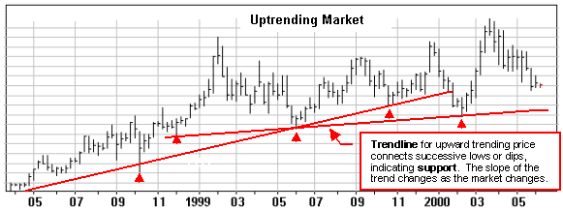
Drawing trendlines during an up trending market: The trendlines above have been drawn by connecting as many successive lows as possible (along the bottom of the price range). An up trending trendline represents major support for prices as long as it is not violated.
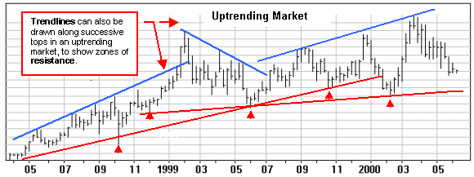
Trendlines connecting highs can also be drawn to indicate the top of the established trend or channel (blue lines). These trendlines indicate the major zones of resistance. (See below for a discussion of support& resistance).
Drawing trendlines in a down trending market. Down trending trendlines are drawn by connecting the successive highs.
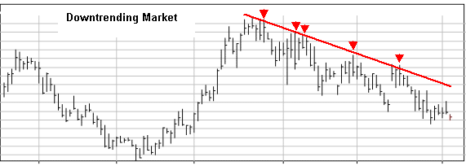
Trends can push and pull the price up or down. Markets can also enter a period of quiet stability where the price forms a horizontal line sideways across the page. A sideways trending market is normally a difficult market to trade for a profit. It can, however, set the stage for a sharp move once the sideways trend is broken (signalled by a price break through a well-established trendline).
A sideways pattern represents stability between supply and demand in the marketplace. Trendlines in this type of market, often referred to as a narrow trading range or congestive phase, are drawn by connecting both the highs and lows. Prices In this type of market can break upward or downward so it is valuable to establish the top and bottom of the range (see the report on Breakout signals)
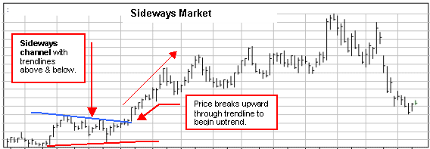

Support and Resistance
An important concept in the use of trendlines is that of support and resistance. A continued trend is based on underlying support for prices in the market, for whatever reason. Similarly, there’s resistance to higher prices built into the market. The trendline is one way to capture and illustrate these zones of support and resistance.
As long as the market stays within these zones of support and resistance, as shown by a trendline, the trend is sustained. Any penetration through a trendline warns of a possible change in trend. We may not know the reason behind such a change, but we do know that for some reason the support or resistance for a market is changing.
The Rhino Theory of Support and Resistance: The upper and lower trendlines contain the price the way a barbed wire fence might contain a rhino. Think of the prices as the rhino and the trendline as a barbed wire fence. If a rhino leans against the wire, the fence will give a bit, offering more and more resistance until either the rhino eases off or the wire snaps. If the rhino has wandered along and leaned against the fence in several places without breaking through, we will have more faith in the strength of the fence.
If the rhino only leaned against the fence once before moving along, it is less meaningful. In charting practice, a line based on one high or one low means nothing. Two highs or lows is the bare minimum. The more points you can connect the more significant the resulting line. And, the more significant the trendline, the more significant any penetration will be. (I say will be because all trends eventually reverse some day!)

Round numbers
Another aspect of resistance and support concerns the round numbers associated with price levels, such as 10, 20, 25, 50, 75 and 100. Since the price reflects the psychology of the marketplace, these levels offer “natural boundaries or targets.” With resistance and support common along these levels, it makes sense to avoid placing orders right at these values. (If buying on a short term dip in an uptrend, you’d place your order just above an important round number). It also makes sense to place stop loss orders below the round numbers on long positions, rather than exactly on the round number (i.e., $4.90 rather than $5.00).

Duration of Trend
Short term trends are established over a few days. It may be in any direction and has little potential over the long run (except if you’re a daytrader). A strong thrust, however, may indicate the beginning of a move into new ground. Particularly if it crosses a medium or long term trend line. Think of it as an early warning system; a sign to be prepared for a larger move.
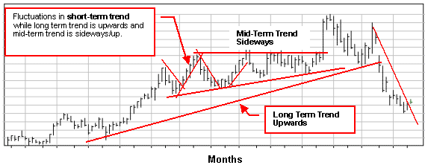
Short term trend -- always the current trend. It may not necessarily be in the same direction as the mid or longterm trend.
Medium term trend -- a trend that occurs over weeks to 2 or 3 months. All big moves must start with a short term thrust building to a medium term trend.
Long term trend -- a trend over three months is considered a long term trend. Long term trends show stability.
Any trend which has continued unbroken for over 3 months is considered to be a long term trend, and of some significance. This is the trend to trade with in the majority of cases. It can be thought of as the driving force behind the price and, until a fundamental change occurs in the marketplace, it will continue to do so.

Signals
Signals are generated primarily when trendlines are broken. A particularly strong signal is generated any time a long term trendline is broken.
Some traders also use the price “bouncing” off a trendline as a signal. If an upward trendline holds, for example, you may have a buying opportunity at a relatively low price. If the price is in a well-established channel, the other side of the channel can give you an approximate price target.
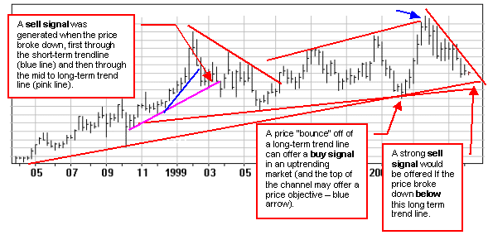

Triangle Patterns
Triangles provide one of the most useful price pattern indicators. The odds favour a continuation of the trend following a breakout from the triangle pattern.

Overview
- When the top and bottom trendlines form a triangle a valuable indicator is formed, often forecasting a sharp subsequent movement when the price breaks out.
- The wider the price fluctuations within the triangle, and the longer the triangle pattern holds, the greater the following price change.
- Good triangles are an intermediate pattern, taking from one to three months to form.
Triangle patterns usually form part way through a strongly trending move and represent a congestive phase in the marketplace. These patterns are important because they are typically followed by sharp increases or declines in price. An established triangle pattern is a valuable signal prior to a relatively predictable price change.
The vertical line measuring the height of the pattern becomes the base of the triangle. The apex is the point of intersection where the two lines meet. There are typically 3 common types of triangles - symmetrical, ascending, and descending:
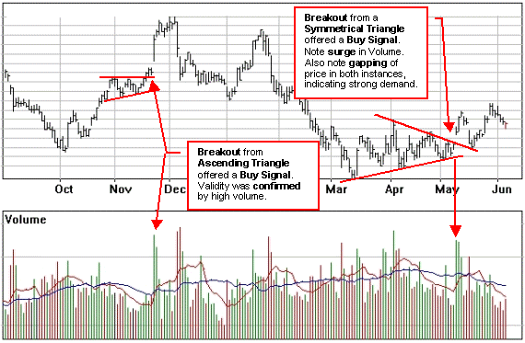

Symmetrical Triangle
The symmetrical triangle is formed by two converging trendlines encompassing at least two or more rallies and reactions with a breakout following the original trend. It is also called a coil because fluctuation in price and volume decrease until both react sharply, like an unsprung coil.
To complete the pattern, volume should pick up noticeably at the penetration of the trendline

Ascending Triangle (Right Angle)
The symmetrical triangle is a neutral pattern, whereas the ascending right triangle is bullish and the descending right triangle is bearish. The ascending triangle has a rising lower line with a flat or horizontal upper line, indicating that buyers are more aggressive than sellers. This bullish pattern usually results in an upward breakout.
This breakout should have a sharp increase in volume and the upper resistance line should act as support on subsequent dips after the breakout. The minimum price target is equal to the height of the base of the triangle measured upward from the breakout point.
The ascending triangle sometimes also appears as a bottoming pattern. Frequently, an ascending triangle will develop toward the end of a downtrend.. Again, the pattern is considered bullish. When demand remains weaker than supply, a bearish ascending pattern may form and is confirmed with a breakout on the downside on good volume.

Descending Triangle (Right Angle)
The descending triangle is a flipped over ascending triangle with a flat bottom line and a declining upper line. A close under the lower trendline, usually on increased volume, resolves the pattern to the downside as bearish. Volume is less important on the downside than on the upside.
If a rally occurs it usually meets resistance at the lower trendline. The descending triangle can also be found at the top of a market.

Volume Accumulation Oscillator
(Chaikin Oscillator)
Volume analysis is important for identifying internal strengths and weaknesses in a market. Very often, a divergence between volume and price movements can offer clues to an impending reversal.

Overview
The Volume Accumulation Oscillator (VAO) -- also called the Chaikin Oscillator after its designer Marc Chaikin -- is more sensitive to volume versus price than the On Balance Volume indicator.
VAO assigns a proportional amount of volume to the price according to the relationship between the closing price and the average price for the day.
- A close above the mean price is given a positive value and a close below the mean a negative value.
- When the market closes at either the high or low of the day, the volume is given full value.
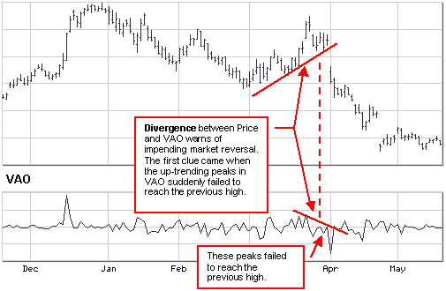
In general, volume oscillators are designed based on the following premises:
- Volume and price normally rise and fall together, and when this relationship changes it can provide an early indication of a coming change in trend.
- The more a market is controlled by buyers (accumulation), the closer it will close to its high. If a market is controlled by sellers (distribution), it will close below its midpoint for the day.
- Lagging volume on an upward move is often a forewarning of a weakening market. A declining market is more complex; usually there's a pickup in volume followed by reduced volume and a period of accumulation before a valid bottom develops.

Interpretation
Divergence between volume and price movement is often the sign that a reversal is about to take place. In the short and intermediate term, the VAO helps to identify market tops and bottoms by sensitively comparing volume to price action.
Most indicators are most effective when used in conjunction with other, complimentary indicators. An effective short and intermediate-term combination of indicators, for example, might include VAO, along with a 21-day moving average and an overbought/oversold oscillator (e.g., Momentum, ROC, CCI).
The VAO is most valuable when:
- in an overbought/sold position, prices reach a new high or low and the oscillator fails to exceed its previous high/low reading and then reverses direction.

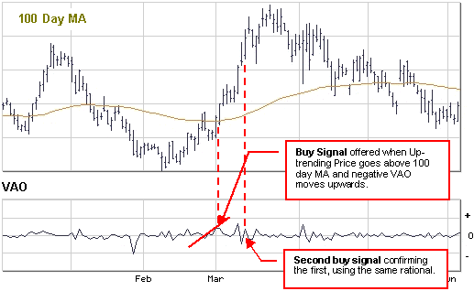

Signals
Buy or sell signals are considered reliable only when they are in keeping with the overall (long-term) trend.
- A buy signal would be generated if an up-trending market is above its intermediate (100-day) moving average, and a negative VAO turns upwards (from a trough).
- A sell signal would generated if a stock is below its 100-day moving average and a positive VAO turns downwards (from a peak).

Further Details
The default VAO is created by subtracting a 10-period exponential moving average of the Accumulation-Distribution Line from a 3-period moving average of the Accumulation-Distribution Line.
William's Accumulation-Distribution
Williams' Accumulation-Distribution tracks the buying pressure and selling pressure.

Overview
Williams' Accumulation-Distribution (WAD) tracks buying pressure (accumulation) and selling pressure (distribution) on a security.
- With accumulation, most of the volume is associated with upward price movement.
- With distribution, most of the volume is associated with downward price movement.
The pressure is determined by where the close sits within today's true range.
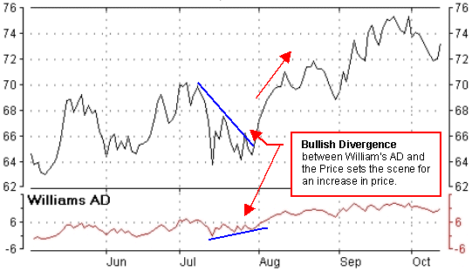

Interpretation
Williams' AD is a running sum of positive accumulation values (buying pressure) and negative distribution values (selling pressure).
- If today's close is higher than yesterday's close, WAD is increased by the distance of the close from today's true low (the lesser of today's low and yesterday's close).
- If today's close is lower than yesterday's close, WAD is decreased by the distance of the close from today's true high (the greater of today's high and yesterday's close).

Signals
Divergence between Williams' AD and the price produces the signals. As with most indicators, WAD leads the price; or in other words, when a divergence occurs, the price usually changes accordingly. For example, if the indicator is moving up and the security's price is going down, prices will probably reverse (as shown in the example above).
- A buying opportunity is signalled by falling prices and a rising WAD
- A selling opportunity is signalled by rising prices and a falling WAD

Earnings per Share or EPS

Overview
EPS, as it is called, is a company's profit divided by its number of shares. If a company earned $2 million in one year and had 4 million shares of stock outstanding, its EPS would be $0.50 per share.
EPS that can be filtered for:
current year current year EPS,
last 12 months EPS,
latest interim EPS,
Next year EPS estimate.
Note that last year's EPS would be actual, while current year and forward year EPS would be estimates.

Dividend Yield

Overview
Gives an indication of the income generated by a share of stock. Dividend yield is calculated by taking the amount of dividends paid per share over the year and dividing by the stock's price. For example, if a stock pays out $1 in dividends over the year, trades at $10, then it has a dividend yield of 10%.

Ex-Dividend Date

Overview
A stock is called "ex-dividend" when buyers are no longer entitled to receive the last declared dividend. Typically, the price falls to reflect the value of the dividend and then rises again later, as shareholders look ahead to the next payout. The Ex-Dividend Date is when this occurs.

Price Earnings Ratio (P/E ratio)

Overview
P/E ratio is used as a measurement of the relative cost of the stock. The P/E ratio is equal to a stock's market capitalization divided by its after-tax earnings over a 12-month period. Whether the calculating for the whole company or a per-share basis, the value is the same.With a high P/E ratio, the market is more willing to pay for each dollar of annual earnings.
Previous year's price/earnings ratio are considered actual (using a historical price), current/next year price/earnings ratio would be estimates. In either case,' P ' is equal to the current price. Companies that are not currently profitable (negative earnings) do not have P/E ratio's.
When comparing acompany's P/E, one should look at comparing the ratio against similar companies. Different industries and even different companies have different P/E ratio's. Technology companies typically have above market P/E ratio's (approx double the average market P/E), while banks have typically have below market P/E ratios.
Understanding the P/E number
A P/E of 40, would mean that it would take 40 years for the investor to see a return on the investment. High P/E ratios can represent low recent earnings, whilst a low P/E ratio could imply low expectations or that the stock is undervalued.
It would be advisavle to also consider comparing the P/E ratio to the growth of earnings per share (P/E divided by growth rate). The resulting PEG ratio can aid the investor in determining whether investor expectations are reasonable given the companies past performance.

Current Assets

Overview
Cash, accounts receivable, inventory, and other assets that are likely to become cash within a year. Strong businesses usually have lots of current assets. Check against current liabilities; since current liabilities should be less than current assets.

Current Liabilities

Overview
Debts or other obligations coming due within a year. These should be less than current assets

